A Health Care Disciplines Project: Establishment of a Specialized Clinic for the Management of Ano-Genital Lichen Sclerosus in a Tertiary Health Care Center in Iraq
Dr. Ahmed M. Lutfi*

*Medical doctor, Anatomist and Dermatologist.
MD, M.Sc. (UK)
College of Medicine, Baghdad University.
Baghdad, IRAQ.
Email/ tesla1452@gmail.com
Phone/ +44 (0)7482 571679 (UK)
+964 (0)7714 338199 (IRAQ)

Executive Summary
Lichen Sclerosus (LS) is a chronic dermatologic condition that mainly affects the genital region, and treatment is mainly with topical medications. However, the disease can have serious complications (including cancer) with profound consequences on the patient’s health, sexual and social life. This part of the project aims to establish a first-of-its-kind specialized clinic (in the largest health care institute in Iraq) for the optimal management of LS and reduction of its complications. Furthermore, this clinic will contribute to the medical community and the medical literature. The project will target a population of 50 patients over a period of 13 months divided into three phases: Phase-1 will focus on securing funds and creating the clinic space, phase-2 will invest in training the medical team, patient enrolment-education and patient management, and phase-3 will focus on patients’ follow-up and project evaluation. The project evaluation will run along all three stages (for analysis and stakeholders’ engagement), which will assess: The reduction in patient expenditure and overall cost on the health care system; the level of activity-success of the clinic; and the possibility of project replication in Iraq and other countries (with similar settings). The main obstacles are: Funding issues; political-financial corruption; and Iraqi society religious-social beliefs that can interfere with female patients’ enrollment. However, effective management of each problem will be deployed. In addition, benefits (especially cost reduction in the long term) will justify such a promising project. By creating an active-successful clinic and using a professional team, the project will: Increase patient-public awareness of LS; effectively treat patients; reduce complications; and improve the patient's quality of life. Collectively, in the long term, this will reduce patient expenditure and the overall cost of the health care system.

Keywords: Lichen Sclerosus, Ano-genital, females, Health Care Disciplines, Specialized Clinic.
Aim(s) of the Project
- To create and organize a multidisciplinary team-based specialized clinic within the Dermatology Unit of the hospital, to practice the optimal management of patients with ano-genital LS.
- Implementation of best practice for this client group to improve quality of life (QoL) and to reduce long-term complications.
Background of the Project – rationale and drivers
- I work as a physician at the largest tertiary health care institute in Iraq, where I have encountered cases of ano-genital LS in various hospital departments. LS can result in appreciable cosmetic, functional and psychological impairments with secondary sexual dysfunction.
- Lichen Sclerosus, a chronic dermatosis primarily affecting the ano-genital area in males, pre-pubertal and peri-menopausal females. Extra-genital sites are less frequently involved. The mainstay treatment is with superpotent topical steroids.
- The driving rationale is to reduce the burden of disease in the selected population through an optimized management protocol in a specialized clinic in concordance with evidence-based guidelines.
- The drivers are represented by the high levels of long-lasting impact and potential complications, such as sexual impairment, psychosocial distress and cancer risk. By acting on the primary disease, this project can significantly reduce future ablative surgical procedures in this unique anatomic area. Patient outcomes will be improved, including quality of life and social activities. Besides philanthropic support, this project could reduce significantly the associated economic burden.
Intended Project Objectives and Outcomes
- Short-term objectives:
- To submit a preliminary project plan to hospital authorities and related committees (academic, medical, scientific and financial).
- To estimate the costs, considering a pilot study of a targeted population of 50 patients (of both genders from all age groups with ano-genital LS).
- Careful selection of members of multidisciplinary team (MDT), consisting of a medical doctor, a nurse, a secretary, a social worker and a psychologist.
- To create a comfortable and welcoming environment for patients’ wellbeing and confidentiality.
- To supply the clinic with related equipment and appropriate furniture.
- Medium-term objectives:
- To educate and train the selected MDT members in using therapeutic protocols according to the current evidence base.
- To coordinate with the pathology department in case of equivocal diagnosis of LS.
- To receive referred patients from other hospital departments (gynaecology, paediatrics, psychiatry and uro-surgical units).
- To utilize therapeutic protocols consisting of superpotent topical steroids (STS) for treating the initial acute inflammatory phase and topical calcineurin inhibitors (TCIs) to manage relapses (Neill et al., 2010).
- Longer-term objectives:
- To support and follow up managed patients using a team approach.
- To reduce the incidence of complications of LS.
- To effectively gather data for a clinical audit and statistical analysis.
- To refine the project plan for further development.
- To perform an economic evaluation to assess the long-term impact.
- To compare the outcome with a parallel project managing cases of ano-genital LS in other countries.

Outcomes (chronological order):
- Establishment of an active and successful specialized LS clinic in Iraq.
- Development of a highly professional MDT.
- Increase the public awareness of LS.
- Reduction of the incidence of LS signs and symptoms.
- Reduction of the incidence of LS complications.
- Reduction of the incidence of malignant transformation risk in LS patients.
- Improvement of patients’ quality of life (QoL), including sexual and psychosocial impact.
- Reduction of patient expenditure within the health care system.
- Cost reduction of the health care system.
Broad overview of Project plan
The timescale will be divided as follows (numbers reflect duration in months):

- Preliminary calculations and preparation (0–2): Overview of the intended project, including costs and population selection criteria. After accessing interviews and negotiations, this step can be repeated in order to re-shape the project into its final forms.
- Interviewing process (1–2): This stage includes an appointment with the hospital General Manager as well as interviews (for authorization and project assessment) with officials in the Regional Health Directorate, Iraqi Ministry of Health and specialized committees (academic, clinical, scientific, ethical and financial).
- Securing project funds (1–2): This stage requires multiple levels of action, starting from the hospital manager up to the level of Regional Directorate or Ministry of Health.
- Choosing the right place for the clinic (2–3): The location should be accessible and in close proximity to other related hospital units.
- Selection of the MDT members (2–3).
- Securing required medications and equipment (2–3).
- Coordination with pathology department (3–4).
- MDT training for the best approach for the patients (3–4).
- Receiving patients (4–12).
- Patient-centered approach of management (4–6): To manage the initial episode of LS with STS and the subsequent use of TCIs.
- Patients’ education (4–12): A vital step should be achieved by means of patient information leaflets, support groups and online resources.
- Follow-up period (6–12).
- Data gathering (4–12).
- Project re-evaluation and subsequent refinement (10.5–12).
- Final statistical analysis and economic evaluation (11–12).
- Extra time for unknown variables (12–13).

Success Criteria
- To create an active LS clinic with a satisfactory number of enrolled patients.
- To effectively reach patients with ano-genital LS.
- To facilitate a harmonious and committed MDT.
- To increase patient satisfaction and understanding.
- To implement effective therapeutic protocols.
- To reduce the incidence of LS complications in the long term.
Critical factors for consideration
- Securing the required funding.
- Difficulty encouraging patients with ano-genital LS to seek treatment.
- Inadequate staff training and support, leading to lack of motivation and/or commitment.
- Unavailability of treatments/medications.
- Failure of therapeutic interventions/adherence due to lack of patient comprehension.
- Difficulties auditing and evaluating the project’s outcomes.

- Introduction
I work as a physician at the Surgical Pathology unit in the largest tertiary health care institute in Iraq, where many LS patients’ histology samples are sent for analysis. Such an illness has a massive impact on patients, patients’ families and the health care system. This project attempts to establish a specialized LS clinic to effectively manage patients using evidence-based guidelines to reduce long-term impact and improve patients’ quality of life while reducing the economic burden on the health care system.
LS is a relapsing dermatosis that occurs mainly in females with tropism of the ano-genital areas. Patients develop long-term psycho-social and sexual dysfunctions; therefore, an MDT approach is mandatory in collaboration with a psychologist, a sexologist and a social care worker. LS used to be considered a variant of Lichen planus or scleroderma; therefore, it is mandatory to confirm the diagnosis of equivocal cases using histology analysis (Bunker & Neill, 2010).
LS incidence is in the range of 1/300–1/1000 in women, with bimodal age peaks (pre-pubertal and peri-menopausal); the male/female ratio is 1:10 (Bunker & Neill, 2010). The high incidence of LS in Iraqi females is an obstacle to effective management due to religious/social background; this must be addressed via patient education and social worker involvement. Additionally, LS can be mistaken for sexual abuse, which is a differential and/or a co-existing trigger mechanism; hence, the involvement of a social worker is vital (Abdelbaky, Aluru, Keegan & Greene, 2012). Vulvar SCC occurs in 5% of patients, which is preventable via long-term follow up (Nasca, Innocenzi & Micali, 2006).
SWOT (strengths, weaknesses, opportunities and threats) analysis was implemented, which is easy, objective and relies on four analytic aspects (Table 1). Internal and external critical factors were explored from the project approval stage to the project’s conclusion. By identifying threats and weaknesses, we can take the required actions. On the other hand, strengths and opportunities can be promoted to achieve practical success. Political-social aspects were explored within SWOT. The political crisis, corruption and social/religious aspects of Iraqi society can greatly interfere with the deployment of this project.
Table 1
SWOT Analysis
STRENGTHS | WEAKNESSES
- Endorsement of a high-priority public health issue.  - A pioneering project that should attract acclaim in Iraq.  - Development of an MDT approach to manage this client group.  - Application of Evidence-Based Medicine (guidelines).  - Enthusiastic / committed hospital consultants and management.  - Focus on ano-genital cases of LS.  - Cost reduction and effectiveness.  - Reduction of patient expenditure within the health care system.  - Improvement of patients’ quality of life. | - Lack of awareness of impact of LS of healthcare workers.  - No existing dedicated service.  - Lack of coordination with other health care institutes.  - This project excludes less critical and less frequent cases of extragenital LS.  - Reluctance of patients due to hazardous side effects of superpotent topical steroids.  - Lack of available data regarding the long-term safety profile of topical calcineurin inhibitors (TCIs).  - Uncalculated-unknown variables.
OPPORTUNITIES | THREATS
- The specialist LS clinic will be a model in Iraq for tertiary health care institutes.  - Contribution to the evidence base of ano-genital LS using disciplined scientific approach.  - Development of a local standardized protocol for LS management.  - Increasing public awareness of LS.  - Prevention of long-term complications, especially malignant transformation.  - Reduction of unneeded invasive and/or ablative surgical interference.  - Improved economic savings due to more effective patient management. | - Lack of support from hospital authorities.  - Failure to secure funding.  - Political and financial corruption.  - Religious-social beliefs may interfere.  - Low quality of health care in the entire hospital.  - Lack of patient referrals (inactive clinic).  - Lack of knowledge (patients or MDT members).  - Wrongly diagnosed or equivocal LS.  - Poor teamwork within the MDT.  - Long-term follow-up period that may interfere with patients’ compliance.
- Strategic Plan
According to SWOT analysis and the models needed for organizational change(s), a strategic plan (Table 2) will be conducted for the best outcome. The institute that I work for belongs to a hybrid machine-political organizational metaphor that tends to have a predetermined set of goals that are achieved via routine operations that lack real MDTs. Dictatorship lies at the top of the institute’s hierarchy, progressing towards anarchy and autocracy at the lower levels, with scattered bureaucracy and a few true MDTs in between. This makes the institution resistant to change(s); hence, understanding the political map of the institute and a planned approach toward authority figures is mandatory. I will use a combination of two models of organizational change: “Lewin’s three steps” and “Kotter’s eight steps” models. Lewin describes a balance between driving versus resisting forces (Figure 1), and manipulation via augmenting driving forces or diminishing resisting forces is required to succeed in Lewin’s first step by “un-freezing” the current status to “move” to a new state, then “refreeze” it (Cameron & Green, 2012).
Kotter, on the other hand, makes organizational change via eight steps (Figure 2), in which change may flourish at the beginning, then decline significantly. To overcome this, certain strategies are to be used (Kanter, 2002): Listening to the environment (feedback), challenging the current organizational status, inspiring others to create a change, making coalitions, then transferring ownership to implementation team(s), learning to persevere and finally rewarding other individuals based on achievements. Moreover, we need to use: A powerful speaker, behind-the-scenes negotiation, goal setting and persistent monitoring of progress (Cameron & Green, 2012). Therefore, a modified approach combining Kotter’s and Lewin’s models will be utilized
.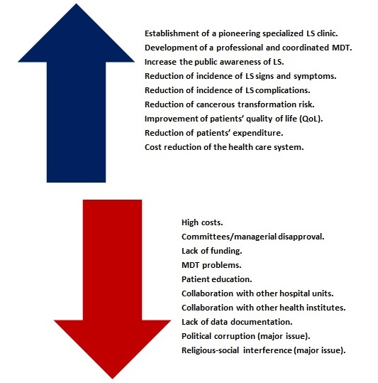
Figure 1. Lewin’s force field analysis (Lewin, 1951).

Figure 2. Kotter’s 8 steps (Kotter, 1995).

Table 2
Strategic Plan
Phase | Objective-Outcome | Issue(s) | Overriding Strategy-tactic(s)
Phase 1 | Initial calculations of project’s cost | - Under/over-estimation of costs.  - Funds’ misallocation to one or more project phases. | - Making a detailed cost allocation with some degree of flexibility.  - Use of professional software(s) to assist in calculations.  - Consulting financial/statistical expert.
 | Interview(s) and approval process | - Managerial disagreements (hospital administrations, regional health directorate and Ministry of Health).  - Committee disapproval or delays (medical, scientific, ethical and financial). | - Good leadership, negotiation and presentation skills.  - Convincing using implied evidence-based guidelines and economic benefits (especially in the long term).  - Re-shaping project plan.
 | Funding | - Absent/insufficient resources (given that it is a public institute).  - Enlisting the project as low priority (waiting list). | - Demonstrating the reasons for making this project a high priority based on long-term benefits and cost effectiveness.  - Using negotiation skills and perseverance.
 | Clinic location | - Small area.  - Noisy/uncomfortable.  - Bad location in relation to other departments.  - Inaccessible for patients/staff.  - Expensive (if rented from private sector). | - To plan from the beginning a comfortable place for patients’ wellbeing and confidentiality, located near referring departments and pathology laboratory.  - Investing more money at this level.  - Renting from private sector.
 | Selection of MDT members | - Poorly qualified MDT members.  - Non-enthusiastic, selfish, unconfident, non-committed MDT members.  - Lack of harmony and communication skills.  - Lack of leadership.  - Lack of motivation for continuous professional development. | - Setting high standards of selection criteria based on CV, professional experience, leadership, interpersonal skills and psychological maturity.  - Investing in creating a positive and encouraging environment.  - To reward with nominal and financial awards.  - To motivate for continuous development.
 | Clinic furnishing and equipment supply | - Inadequate furnishing.  - Low standards  - Lack of sanitation procedures.  - Electricity supply (major issue in Iraq). | - Adequate financial allocation.  - Buying directly from supplier.  - Adequate sanitation protocols.  - Ensuring constant supply of electricity, buying a private electric generator.
Phase 2 | MDT education-training | - Lack of teaching resources.  - Defective teaching technique.  - Poor training.  - Disagreement with some of project’s concepts. | - Using variety of teaching resources (leaflets, books, audio-video materials and practical skills development for performing biopsies, assessing disease severity with relevant scoring systems).  - Full explanation-discussion of concepts and objectives to reach shared points of agreement.
 | Coordination with related hospital units | - Defect in ground rules agreement, including inclusion criteria.  - Bad communication skills beyond the clinic level.  - Bad communication technologies (phones, internet, etc.)  - Patient referral errors. | - Establish clear ground rules.  - Inclusion criteria: Patients with confirmed non-equivocal ano-genital LS, regardless of the limits of gender and age.  - Effective inter-departmental communication.  - Ensuring adequate communication methods.
 | Coordination with pathology laboratory | - Defect in ground rules agreement.  - Lack of biopsy/cytology materials.  - Lack of training for performing biopsy/cytology procedures. | - Clear ground rules.  - Training for laboratory-related procedures in collaboration with laboratory unit.  - Ensuring consistent supply of laboratory-related materials.
 | Coordination with other tertiary health care institutes | - Lack of ground rules.  - Limitations of clinic’s capacity of 50 patients.  - Inter-institutional issues. | - Effective inter-institutional communication via institute’s authority, bearing in mind the clinic’s limited capacity.
 | Receiving patients | - Wrong referral.  - Referral of equivocal LS cases.  - Faulty diagnosis as LS clinically.  - Laboratory errors (faulty histology results). | - Effective use of patients’ inclusion criteria.  - Using histology-cytology analysis in doubtful cases.  - Quality control assurance.
 | Patient orientation-education | - Lack of involvement of either the MDT or patients.  - Lack of teaching resources, time allocation and motivation. | - Effective modern teaching technique using: Information leaflets, support groups and online resources.  - Motivating patients and their families.  - Involvement of social worker and psychologist.
 | Patient-centered management | - Medication unavailability.  - Issues related to adverse effects of STS and TCIs.  - Patient compliance.  - Lack of family support.  - MDT member(s) incompetence. | - Coordination with hospital or external pharmacies to ensure persistent supply of medications.  - Explanatory efforts concerning application methods and adverse effects of STS and TCIs.  - Involvement of social worker and psychologist.  - Regularly assessing MDT members’ performance, replacing them if necessary.
Phase 3 | Patients’ follow up | - Lack of patient compliance.  - Patient withdrawal/dropout.  - Therapeutic failure or frequent relapses.  - Complications and therapeutic-related adverse effects. | - Enhancing motivation.  - Inclusion of patient’s family.  - Good advertisement of clinic.  - Using strict therapeutic protocols.
 | Data gathering | - Incomplete data gathering.  - Loss of data  - Database errors.  - Withdrawn patients. | - Persistent collection of high-quality data.  - Creation of accurate databases.  - Consulting specialists.  - Encouraging patients to persist.
 | Economic evaluation | - Economic fluctuations.  - Foreign policy factors.  - Financial distress (major issue in Iraq).  - Faking statistical-financial data driven by corruption (major issue). | - Fighting corruption via adequate reporting to effective authorities.
 | Final statistical analysis | - Defect in collected data, may result in bias.  - Human mistakes.  - Computer software-related errors. | - Consulting experts.  - Utilization of high-quality software.
 | Extrinsic unknown factor(s) | - Unknown.  - Miscalculated. | - Allocation of extra time/funding.

- Operational Plan
The project runs with overlapping phases, as demonstrated in the Gantt chart (Figure 3), which is an objective and conclusive chart for displaying various phases and sub-phases (Kosara & Miksch, 2002).. The project will span 13 months starting from January 1st 2016 to February 1st 2017. The project is composed of three main phases with a related milestone at the end of each phase (milestone 1, 2 and 3).
Phase 1 will be composed of six stages (01/01/2016–01/04/2016):
- Preliminary estimation of costs.
- Interview(s) with the related authorities/committees to reach a project’s approval.
- Securing project funds, this step will run simultaneously with step 2.
- Clinic site localization.
- MDT member selection.
- Securing medications and related equipment. Steps 4, 5 and 6 will run simultaneously.
Phase-2 will be composed of four stages (01/04/2016–01/01/2017):
- MDT training.
- Coordination with Pathology department. This step will run in parallel with step 1.
- Receiving patients and patient education.
- Patient medical management, followed by patient follow up for relapses (in phase 3).
Phase 3 will be composed of four stages (01/04/2016–01/02/2017):
- Patient follow up, starting at the end of phase 2/step 4.
- Data gathering, a continuous process.
- Final statistical analysis and economic evaluation.
- Extra time for unknown/miscalculated variables at the end of project.
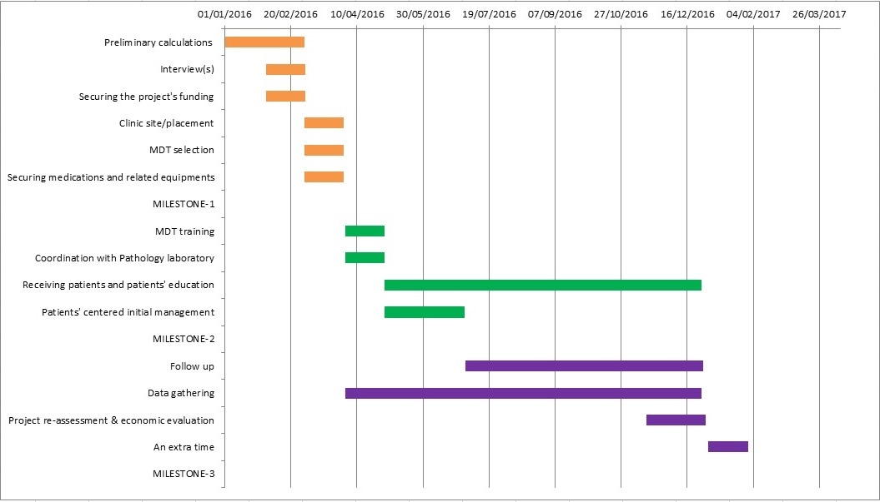
Figure 3. Gantt chart.
- Leadership Approach
The machine metaphor (mentioned before) requires leaders focused on very specific clear goals to work in well-structured environments. On the other hand, the ideal leader for working within a political system organization should be closely involved with powerful/influential people. However, overuse of such models may result in a narrower view of outcomes with little risk taking (machine metaphor) and/or a manipulative status (political metaphor) (Cameron & Green, 2012).
A complete leader would have: Innovative ideas, originality, constant and progressive development, a long-range view, an inquiring attitude, challenging traits and a strong personality. Unfortunately, this utopic model (perfection) does not apply to the majority of people; Bennis (1984) described four essential traits for leadership that are based on the management of: Self, trust, attention and meaning. Another interesting point is the emotional intelligence factor (Goleman, 1998), which is based on: Self-awareness, self-management, social awareness of others and social skills for inducing changes.
I identify myself as a “transformational leader”, being charismatic, motivating, intellectual and self-aware/managing (Bass & Avolio, 1993). I have been developing since I was a medical student with great communication skills (I was always admired by others, then later as a motivating and communicative university teacher), the ability to organize and motivate a team (I was a student representative in two UK universities, similarly at work and on my basketball team), objectivity, authenticity, the ability to identify others’ qualities and weaknesses, and the ability to multi-task. My leadership defects include: Impulsivity, focusing on short-term rather than long-term objectives and performing multiple tasks with a lack of full focus on each task. These defects can be bypassed by: Consulting a financial expert for project cost estimation, referring to the private sector to determine the best clinic location, collaborating with a psychology analyst during interviewing for MDT selection, transferring ownership to an implementation team (medical MDT for LS management), coordinating with other hospital units via the clinic MDT, conducting statistical/economic evaluation by consulting an expert, being open to feedback and referring to assertive authorities instead of colliding with corruptive elements.

- Team Considerations
Dyer, Dyer Jr and Dyer (2007) described four determinants, named the four “Cs”, of high-performing teams (Figure 4).

Figure 4. The 4 “Cs” of high-performing teams.
As a project leader, I will conduct the selection process in collaboration with a psychology analyst/profiler. Selection will be based on a CV, professional experience and, most importantly, psychological maturity/suitability (for the MDT environment).
Ground rules will be set immediately after the MDT-selection process, understanding each member role and the expected project outcomes. Moreover, I intend to be open to ideas and feedback via regular meetings. At the same time, I will be assertive in my leadership. The MDT will be composed of: A secretary, medical doctor, nurse, psychologist and social worker. A patient-centered approach, using evidence-based guidelines and pre-agreed ground rules, will be implemented (Table 3).
Table 3
Members of LS Clinic MDT
Team Member | Secretary | Medical doctor & nurse | Social worker | Psychologist
Tasks | - Administrative duties.  - Communication/coordination with other departments (including laboratory unit) based on ground rules set by the MDT.  - Initial welcoming of patients to make them feel comfortable. | - Coordinate-lead the MDT.  - Both work in parallel.  - Manage and follow up patients in collaboration with other team members in concordance with guidelines and MDT-agreed ground rules.  - Refer equivocal LS cases for histology.  - Manage complications and/or refer them to the relevant departments  - Monitoring for malignant changes.  - Coordinate regular MDT meetings. | - Dedicate to patients and their families.  - Conduct interviews to review their situation and write detailed evaluation in collaboration with psychologist.  - Offer relevant support.  - Recommend the best action in a certain situation.  - Coordinating with relevant agencies outside the MDT.  - Participate in regular MDT meeting & training.  - Record data from legal perspective.  - Pay attention to features of sexual abuse (in case of pediatric patients). | - Regular Assessment  - Set goals to achieve optimum mental health.  - Short-term help in case of acute stressful event.  - Long-term help for LS patients with long-standing mental health illnesses.  - Managing patients by referring them to psychiatrist and/or hospitalization.  - Implementation of psychotherapy, including group therapy, which is suitable in this clinic setting.  - Collaboration with sexologist and marriage counselling for couples  - Involvement of patients’ families.
Considerations | - Lack of understanding of disease nature.  - Poor documentation skills.  - Lack of emotional intelligence for dealing with patients. | - Poor doctor-nurse interaction, leading to MDT fragmentation.  - Poor appreciation of Iraqi religious-social background, especially concerning Iraqi females. | - Patients’ non-compliance with non-medical personnel  - Poor communication skills.  - Non-supportive patient families. | - The long psychosocial impact is mostly beyond the psychologist, leading to frequent referrals outside the clinic that may jeopardize the project-allocated funds.

- Prospective Evaluation Strategy
Wimbush and Watson (2000) described six stages of project development using the Health Education Board of Scotland (HEBS) evaluation framework (for a health promotion project), from project planning to its dissemination and replicability potential (Figure 5). Green and South (2006) state (for projects undertaken within the public health practice) that the use of the six-step evaluation framework was successful. However, the University of Kansas community tool box for project evaluation is an excellent model for evaluating my project in a dynamic way with more emphasis on the learning experience and feedback (particularly to key stakeholders). Therefore, a hybrid model of these two will be implemented, which will make it more suitable for: Geographic boundaries, social-religious background and political instability in Iraq (a summary of the evaluation plan is described in Figure 6).

Figure 5. Stages of project development.
Figure 6. A concept map, summary of prospective evaluation plan and evaluation parameters.

Milburn et al. (1995) justify the use of combinations of methods/tools of evaluation to: Achieve more depth of evaluation, strengthen the evidence and to assume a different perspective on the same issue. Therefore, I used a combination (as detailed in Table 4 and Figures 7 and 8, each tool will be used on a monthly basis) of both quantitative and qualitative methods: Interviews, peer review, observation, user logs, utility usage and clinical data (JISC project planning, 2013). This choice was influenced by ethical considerations and the nature of the targeted population. The evaluation purposes are: The learning experience, to deepen the understanding, transparency and improved communications (Keyonzo, 1989).
Table 4
Detailed Analysis of Evaluation Tools/Methods and Time Frames
Phase | Evaluation parameter (outcome) | Tool of evaluation | Timing
2 & 3 | Professional MDT | Questionnaire (MDT) | 1/3/2016 – 1/1/2017
 |  | User logs (MDT)
 |  | Utility usage (MDT)
 |  | Peer reviews
 |  | Interviews & psychometric profiling
 |  | Clinical observation | 1/5/2016 – 1/1/2017
 |  | Clinical data
 |  | Focus groups (patients)
2 | Level of clinic activity | User logs (MDT & patients) | 1/5/2016 – 1/7/2016
 |  | Utility usage (MDT & patients)
 |  | Observation (clinic/departments)
 | Public awareness of LS | Questionnaire (public people)
 |  | User logs (patients)
 |  | Clinical data (patients)
2 & 3 | Patient education | Questionnaire | 1/5/2016 – 1/1/2017
 |  | User logs (patients)
 |  | Utility usage (patients)
 |  | Clinical data
2 & 3 | Incidence of LS clinical features | VAS-BP & VAS-PR Questionnaire | 1/5/2016 – 1/1/2017
 |  | Clinical data (LS complications) | 1/7/2016 – 1/1/2017
 |  | User logs (complicated cases, outside clinic)
3 | Incidence of LS complications | Clinical data | 1/7/2016 – 1/1/2017
 |  | User logs (inside clinic)
 |  | User logs (outside clinic)
 |  | Utility usage (diagnostics)
 |  | QoL Questionnaire
3 | Patient QoL & psychosocial impact | QoL Questionnaire
 |  | Expenditure Questionnaire
 |  | User logs (patients)
 |  | User logs (MDT)
2 & 3 | Patient expenditure | Expenditure Questionnaire | 1/5/2016 – 1/1/2017
 |  | Utility usage (patients)
3 | Overall cost of health care system | Economic evaluation | 15/12/2016 – 1/1/2017
 |  | Clinical data | 1/5/2016 – 1/1/2017
3 | Project replicability potential | All above parameters | 1/1/2017 – 1/2/2017
 |  | Economic evaluation | 15/12/2016 – 1/1/2017

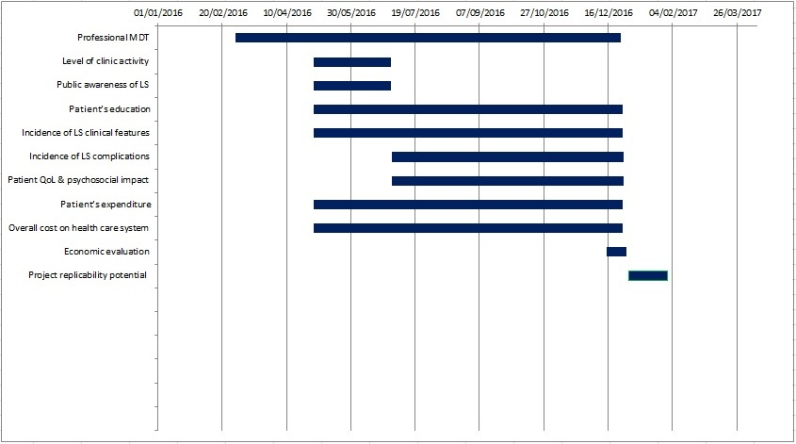
Figure 7. Bar chart, demonstrating the chronology of outcomes (evaluation parameters).
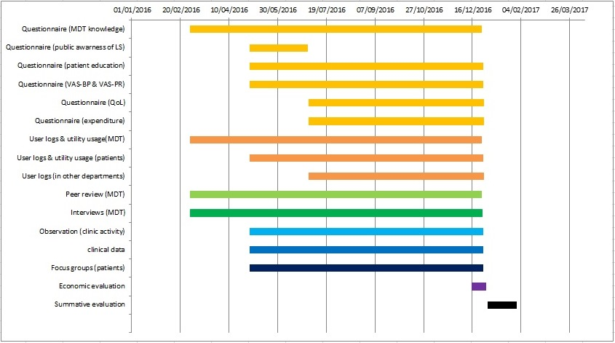
Figure 8. Bar chart, demonstrating the chronology of tools/methods of evaluation.

Table 5
Prospective Evaluation Plan
Outcome | Indicators of success | Tools/methods of evaluation | Time frame |  | Dissemination plan
SHORT TERM
- Level of activity of the clinic. | - High number of patient enrolments per day.  - High number of patient referrals from other hospital departments.  - High frequency of monthly admissions per patient.  - High use of LS clinic facilities and Multidisciplinary Team (MDT) resources.  - High number of patient referrals to collaborating departments.  - High number of MDT-working hours. | - User logs and utility usage logs (for patients and MDT members in clinic and related departments).  - Observation (of clinic activity and related departments). | - Formative evaluation, in parallel with phase 2 of the project. |  | - Hospital newsletter.  - Reporting to key stakeholders, particularly funding bodies-financial committees.
- Professional MDT. | - Effective teaching methods-learning resources.  - Excellent theoretical-practical knowledge.  - Optimal coordination with other departments’ MDTs.  - Comfortable environment.  - MDT motivation/harmony.  - High use of resources available to MDT.  - Overall patient satisfaction towards their MDT. | - Questionnaire for MDT members (to test the adequacy of teaching resources and their knowledge).  - User logs and utility usage logs (for MDT members).  - Peer review.  - Interview-psychometric profiling (harmony and motivation of MDT).  - Observation (of clinical practice).  - Focus groups (patient satisfaction toward MDT).  - Clinical data (patient improvement). | - Formative evaluation, in parallel with phases 1, 2 and 3.
- Public awareness of LS. | - Increased knowledge.  - Higher number of patient enrollments in LS early stages.  - A satisfying number of female vs. male patient enrolments (female restraint due to Iraqi society religious-social backgrounds). | - Questionnaire (to test knowledge of LS).  - User logs.  - Clinical data. | - Formative evaluation, in parallel with phase 2.  - Summative evaluation. |  | - Hospital newsletter.
- Patient education. | - Increased patient knowledge of LS.  - Low incidence of LS complications, including malignancy.  - Reduction of monthly frequency of admissions per patient in Phase-3-follow-up period.  - Efficient use of clinic resources and therapeutic options.  - Maximum number of hours of utility usage at home. | - Questionnaire (patient knowledge of LS).  - User logs and utility usage (for patients, in clinic and at home).  - Clinical data (LS complications). | - Formative evaluation, in parallel with phases 2 and 3.  - Summative evaluation. |  | - Ward rounds.
- Incidence of LS clinical features. | - Reduction of pain, bleeding, burning sensation and pruritus (recorded on Visual Analogue Scale-VAS).  - Low incidence of LS relapses and complications.  - Lower frequency of monthly admission to LS clinic, achieved in phase-3-follow-up period. | - Questionnaire (to assess VAS-BP and VAS-PR).  - Clinical data.  - User logs (outside clinic for complicated cases). | - Formative evaluation, in parallel with phases 2 and 3.  - Summative evaluation. |  | - Ward rounds.
MEDIUM TERM
- Incidence of LS complications. | - Reduction of scarring, uro-genital complications, sexual impairment and malignancies.  - Reduction of use of diagnostic procedures-sampling technique.  - Higher scoring in patients’ quality of life indices.  - Lower frequency of monthly admissions to LS clinic, achieved in phase-3-follow-up period.  - Reduction of consultations-referrals to other departments. | - Clinical data (complication incidence).  - User logs (patient enrolment and referrals in phase 3).  - Utility usage logs (diagnostic procedures).  - Quality of Life (QoL) Questionnaire. | - Formative evaluation, in parallel with phase 3.  - Summative evaluation. |  | - Ward rounds.  - Hospital newsletter.  - Key stakeholders-funding bodies.
- Patient QoL, Sexual and psychosocial impact. | - Higher scoring in QoL, sexual QoL and better psychosocial performance.  - Reduction of patient expenditures on LS management.  - Lower frequency of patient-monthly visits and clinic activity in phase 3. | - Questionnaire (QoL indices and patient expenditure).  - User logs (patients).  - User logs and utility usage (MDT).
LONG TERM
- Patient expenditure. | - Reduced monthly expenditure in clinic (reduction should increase as we progress toward phase 3)  - Reduced expenditure within tertiary health institute.  - Lower expenditure on social care services and mental counselling.  - Lower overall monthly expenditure due to QoL improvement. | - Questionnaire (expenditure).  - Utility usage. | - Formative evaluation, in parallel with phases 2 and 3.  - Summative evaluation. | - Article in local press.  - Hospital newsletter.  - Key stakeholders and funding bodies.
- Overall cost of health care system. | - Lower cost due to reduction of LS complications and enhancement of QoL  - Lower utilization of clinic resources.  - Fewer referrals to other medical units. | - Economic evaluation.  - Clinical data.
- Activity-success of clinic and potential project replicability. | - High number of patient enrolments (phase 2) vs. lower patient enrolment towards phase 3.  - Effective MDT.  - Educated patients.  - Reduction of LS complications.  - Enhancement of QoL.  - Reduced cost for patients and health system.  - Endorsement by high-level managers and policy makers. | - Summative evaluation  - Economic analysis. | - Summative evaluation. | - Journal article.  - International conference.

The outcomes (to be evaluated) were divided into short, medium and long term. The long-term outcomes are: Cost reduction for the patient-health care system and project potential for replicability. Furthermore, the planning framework for evaluation should be agreed upon with key stakeholders (Green & South, 2006). The key stakeholders are development agencies, funding bodies, intended beneficiaries and the project team (Dasgupta & Marglin, 1972). The prime benefits of this project that will interest stakeholders are:
- Cost reduction of the health care system due to: The reduction of complications, management approach via MDT (using the most recent guidelines-evidence-based practice) and improvement of quality of life.
- Learning experience: This project is the first of its kind in Iraq.
- Increased patient-public awareness of Lichen Sclerosus (LS).
The project will be a success in terms of the 5 Es: Efficacy, efficiency, effectiveness, elegance and ethical considerations (Green and South, 2006); however, potential flaws of the evaluation parameters-tools are:
- The lack of evaluation parameters/tools for the period before MDT selection. However, that period is inactive, during which project funding is secured and the clinic is being furnished.
- The level of clinic activity: A high frequency of monthly admissions may arise from the wrong-equivocal diagnosis of LS.
- The high use of diagnostic procedures (seen in the utility logs) may arise from the high rate of complications-therapeutic failure.
- Patient education: The decline of patient monthly enrollment could be due to patient withdrawal rather than success in patient education.
- Patient expenditure: This may reflect patient economic status or the lack of motivation-belief in the offered therapeutic protocol.
- Cost of health care system: Lower expenditure may relate to financial-political corruption and/or low funding allocation.
- Religious-social beliefs may cause lower female attendance. Accordingly, the tools of evaluation (logs and clinical data) should be scrutinized for both genders.
- The tools of evaluation are numerous (Table 4 and Figures 7 and 8), and they are to be used on a monthly basis (cost reduction). Questionnaires and user logs/utility usage logs account for more than half of the tools (Figure 9). Both tools have large data sets. MCQ-type Questionnaires are better (for statistical purposes) and can provide data on personal behavior, thoughts and feelings (Steckler et al., 2002). Clinical data and economic analysis are to be conducted by statistical specialists.
- Dependence on user logs/utility usage logs can be faulty due to: Patient drop-out or MDT lack of commitment/attendance to the project.
- There is a concentration of evaluation tools (period 1/7/2016–1/1/2017, seen in Table 4 and Figure 8). Therefore, the reduction of the monthly frequency of an evaluation tool is required.
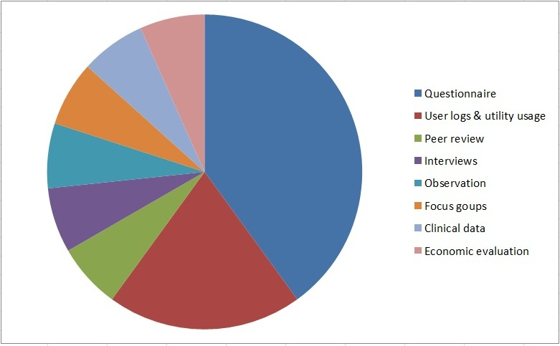
Figure 9. A pie chart, showing the relative ratios of evaluation tools used in project evaluation.

References
Abdelbaky, A. M., Aluru, P., Keegan, P., & Greene, D. R. (2012). Development of male genital lichen sclerosus in penile reconstruction skin grafts after cancer surgery: An unreported complication. BJU International, 109(5), 776–779.
Bass, B. M., & Avolio, B. J. (1993). Transformational leadership and organizational culture. Public Administration Quarterly, 112–121.
Bennis, W. (1984). The Four Competencies of Leadership. In: An Invented Life: Reflections on Leadership and Change (pp. 1–6).
Burrows, L. J., Creasey, A., & Goldstein, A. T. (2011). The treatment of vulvar lichen sclerosus and female sexual dysfunction. The Journal of Sexual Medicine, 8(1), 219–222.
C. B. Bunker & S. M. Neill. (2010). The Genital, Perianal and Umbilical Regions. In: B. Tony, B. Stephen, C. Neil, G. Christopher (Eds.), Rook’s Textbook of Dermatology (8th ed., pp. 3705–3806). Oxford, UK: Wiley-Blackwell.
Cameron, E., & Green, M. (2012). Making Sense of Change Management: A Complete Guide to the Models, Tools and Techniques of Organizational Change. 3rd ed. England: Kogan Page.
Chi, C. C., Kirtschig, G., Baldo, M., Lewis, F., Wang, S. H., & Wojnarowska, F. (2012). Systematic review and meta-analysis of randomized controlled trials on topical interventions for genital lichen sclerosus. Journal of the American Academy of Dermatology, 67(2), 305–312.
Dasgupta, P., Sen, A., & Marglin, S. (1972). Guidelines for Project Evaluation. Guidelines for Project Evaluation.
Dyer, W. G., Dyer, W. G., & Dyer, J. H., (2010). Team Building: Proven Strategies for Improving Team Performance (4th ed.). England: Wiley.
Fistarol, S. K., & Itin, P. H. (2013). Diagnosis and treatment of lichen sclerosus. American Journal of Clinical Dermatology, 14(1), 27–47.
Funaro, D., Lovett, A., Leroux, N., & Powell, J. (2014). A double-blind, randomized prospective study evaluating topical clobetasol propionate 0.05% versus topical tacrolimus 0.1% in patients with vulvar lichen sclerosus. Journal of the American Academy of Dermatology, 71(1), 84–91.
Goldstein, A. T., Creasey, A., Pfau, R., Phillips, D., & Burrows, L. J. (2011). A double-blind, randomized controlled trial of clobetasol versus pimecrolimus in patients with vulvar lichen sclerosus. Journal of the American Academy of Dermatology, 64(6), e99–e104.
Goleman, D. (1998). Working with Emotional Intelligence. London: Bloomsbury.
Green, J., & South, J. (2006). Evaluation: Key concepts for public health practice.
Jisc: Creative Commons BY-NC-ND (2013). Project planning: Evaluation plan. Retrieved from: http://www.webarchive.org.uk/wayback/archive/20140614222613/http://www.jisc.ac.uk/fundingopportunities/projectmanagement/planning/evaluation.aspx
Kanter, R. (2002). The enduring skills of change leaders. In: F. Hesselbein and R. Johnston (Ed.), On Leading Change, (pp. 47–59). New York: Jossey-Bass.
Keyonzo, N. A. (1989). Project evaluation guidelines. Afya, 23(1), 25.
Kosara, R., & Miksch, S. (2002). Visualization methods for data analysis and planning in medical applications. International Journal of Medical Informatics, 68(1), 141–153.
Kotter, J. P. (1995). Leading change: Why transformation efforts fail. Harvard Business Review, 73(2), 59–67.
Lewin, K. (1951). Field Theory in Social Science. New York: Harper and Row.
Milburn, K., Fraser, E., Secker, J., & Pavis, S. (1995). Combining methods in health promotion research: Some considerations about appropriate use. Health Education Journal, 54, 347–56.
Nasca, M. R., Innocenzi, D., & Micali, G. (2006). Association of penile lichen sclerosus and oncogenic human papillomavirus infection. International Journal of Dermatology, 45(6), 681–683.
Neill, S. M., Lewis, F. M., Tatnall, F. M., & Cox, N. H. (2010). British Association of Dermatologists’ guidelines for the management of lichen sclerosus 2010. British Journal of Dermatology, 163(4), 672–682.
Patsatsi, A., Kyriakou, A., Vavilis, D., Mantas, A., Patsialas, C., & Sotiriadis, D. (2013). A therapeutic approach for female, relapsing genital lichen sclerosus: A single-center study. Journal of Dermatological Treatment, 24(5), 336–339.
Rathi, S. K., & D’Souza, P. (2012). Rational and ethical use of topical corticosteroids based on safety and efficacy. Indian Journal of Dermatology, 57(4), 251.
Steckler, A. B., Linnan, L., & Israel, B. A. (2002). Process evaluation for public health interventions and research (pp. 1–23). San Francisco, CA: Jossey-Bass.
University of Kansas (n.d.). Community Tool Box. Part J. Evaluating Community Programs and Initiatives. Retrieved from: http://ctb.ku.edu/tools/en/tools_toc.htm#partJ
Wimbush, E., & Watson, J. (2000). An evaluation framework for health promotion: Theory, quality and effectiveness. Evaluation, 6(3), 301–321.

