Title: The role of myostatin in alcohol and hypertensive cardiac diseases.

Authors: Joaquim Fernández-Solà M.D., Ph.D¹, and Ana Planavila Porta Ph.D. ²

¹Alcohol Research Unit. Department of Internal Medicine.
Hospital Clinic, University of Barcelona. Spain.

² Departament of Biochemistry and Molecular Biomedicine.
Faculty of Biology. University of Barcelona. Spain.

Address of correspondence:
Joaquim Fernández-Solà. Department of Internal Medicine.
Hospital Clínic, Villarroel 170. 08036. Barcelona. Spain
E-mail: Jfernand@clinic.ub.es
Phone: 34.659107529

KEY WORDS: MYOSTATIN, HEART, ALCOHOL, HYPERTENSION, CARDIOMYOPATHY, HEART HYPERTROPHY, CARDIOMYOKINES.

ABSTRACT

Myostatin (GDF-8) is a major regulatory factor on cardiac metabolism, function and energy homeostasis. Although the main site for myostatin expression is the skeletal muscle, it has a relevant role in heart pathophysiology. Myostatin up-regulation inhibits cardiac myocyte proliferation and protects the cell from apoptosis. Myostatin disruption induces myocyte hyperplasia, hypertrophy and proliferation, increasing global cardiac mass. Myostatin up-regulation appears after different pathological heart conditions such as ventricular hypertrophy and chronic heart failure.
Alcohol misuse up-regulates myostatin cardiac expression, a fact similar to that happens in hypertension or other causes of cardiomyopathy (CMP). In the case of chronic alcoholics, this myostatin up-regulation is higher and the heart proliferation ratio lower compared to other groups with CMP. In the presence of isolated hypertension myocardial myostatin activity is not modified, but in hypertensive CMP, heart myostatin expression is clearly increased.
The presence of structural dilated CMP induces a significant increase in heart myostatin expression independently of their etiology, either in alcoholic, hypertensive, valve, ischemic or idiopathic CMP. In the setting of heart failure, myostatin expression is also up-regulated independently of their etiologic cause, especially in end-stage heart failure. Myostatin up-regulation probably appears to limit the compensatory but excessive cardiac growth. It contributes to restrict unhealthy repair mechanisms mostly myocyte hypertrophy and proliferation and also regulates heart energy homeostasis.
In addition to myostatin, other novel cardiomyokines such as IGF-1, FGF21 and Metrnl appear to have a relevant role in regulation of cardiac hypertrophy and remodelling. These cardiomyokines have also been proposed as diagnostic markers and potential therapeutic agents.
In alcohol and hypertensive heart diseases, in addition to decrease heart aggressive factors (alcohol intake, hypertension overload), control of local cardiac neuro-hormonal pathways will be relevant points to consider in the future.

1.- INTRODUCTION

The pathophysiologic role of Myostatin in human health and disease has been partially clarified over the last decades (Argiles, 2012). Myostatin (Mstn) is the growth and differentiation factor 8 (GDF-8), a member of the transforming growth factor-β superfamily of growth factors which acts as the major negative regulator of skeletal muscle growth (Gausin & Depre, 2005), (Sharma et al., 2015). But Mstn also plays a major role in the regulation of metabolic processes including glucose metabolism, body fat content, energy homeostasis and also influences the cardiovascular function (Kemaladewi et al., 2012), (Biesemann et al., 2014).
The main site for Mstn expression is the skeletal muscle, where its inactivation produces a vast increase in muscle mass similar in humans as in other animal species (Salzler et al., 2016). However, Mstn is also significantly expressed in the heart and fat tissue (Karlowatz RJ, 2011) (Dschietzig, 2014). A relevant role of Mstn in heart patophysiology has been recently evidenced. The significance of Mstn dysregulation in childhood versus adult heart tissue is clearly different (Biesemann, 2014). Myostatin up-regulation inhibits adult cardiac myocyte proliferation and protects the cell from apoptosis. Therefore, during tissue development it is down-regulated (Joulia Ekaza & Cabello, 2006). Myostatin disruption induces increased cardiac mass with myocyte hyperplasia and hypertrophy and stimulates myocyte cell proliferation (McKoy, Bicknell, Patel & Brooks, 2007).
Myostatin up-regulation has been observed after different pathological heart conditions such as ventricular hypertrophy (Rodgers et al., 2009), volume overload (Shyu, Lu, Wang, Sun & Chang, 2006), mechanical unloading (Bish et al, 2011), chronic heart failure (George et al., 2010), (Baan et al., 2015), and acute myocardial infarction (Castillero et al, 2015). Other members of the Mstn family such as GDF-11 have antagonistic effects, reversing the age-induced cardiac hypertrophy (Loffredo et al., 2013). These evidences lead to consider a major regulatory role of Mstn family molecules in cardiac mass, proliferation and growth regulation. To avoid cardiac hypertrophy attempts to inactivate Mstn have showed different results being germ-line inactivation strategies less useful than control of constitutive Mstn overexpression (Heineke et al, 2010). This implies a differential role of Mstn inhibition in the heart during childhood development versus adult heart. Biesemann et al (2014) have also pointed the potential relationship that may exist between the different roles that Mstn exerts on the heart, in fact integrating the effects on cardiac growth, myocyte proliferation and metabolic and energy regulation. On this sense, conditional inactivation of Mstn in a model of adult mice produces glycolysis and increased glycogen storage, cardiac hypertrophy and heart failure with increased animal mortality (Shyu Lu, Wang, Sun &, Chang, 2006).
The role of Mstn on heart homeostasis regulation is relevant to prevent cardiac hypertrophy and avoid heart failure (Baan et al., 2015), (George et al., 2010). It is also relevant to consider that Mstn interacts with other cardiac regulatory factors such as IGF-1 (Morissette , Cook , Buranasombati , Rosenberg & Rosenzweig , 2009) and the final result on cardiac plasticity and function depends of a variety of factors, sometimes counterposed (Hill & Olson, 2008), (Tham, Bernardo, Ooi, Weeks & McMullen, 2015).

2.- ALCOHOL AND MYOSTATIN
Alcoholic cardiomyopathy (ACM) is a major consequence of alcohol misuse that appears as a progressively dilated CMP in long-standing alcohol abusers in a dose-dependent manner (Guzzo-Merello, Cobo-Marcos, Gallego-Delgado & Garcia-Pavia, 2014). ACM is a major complication of alcoholism, being responsible of high morbidity and mortality indices in this population. Mechanisms of alcohol-induced cardiac damage are multi-factorial and synergistic (Fernández-Solà, 2015), with changes in membrane permeability and composition, disturbances in calcium transients and receptors, disruption of excitation-contraction coupling mechanisms, metabolic disruption of protein synthesis, glycogen and lipid regulation as well as changes in energy and genetic cell control. In ACM this progressive alcohol-induced cardiac damage trough different synergic mechanism lead to progressive cardiomyocyte loss mediated by myocyte apoptosis (Fernández-Solà et al., 2006). After myocyte loss, the remaining cardiac myocytes develop hypertrophy and interstitial fibrosis, producing a progressive ventricular dysfunction. In addition to this lesion mechanisms, it is relevant to consider that heart in ACM loss its homeostatic regulation and the compensatory mechanisms that could minimize the damaging effect of alcohol on the heart also diminish (Urbano-Marquez & Fernández-Solà, 2004). The heart is a plastic organ, able to repair and compensate most of the injuries that receives (Hill & Olson 2008). However, alcohol abuse induces a decrease in myocyte proliferation rate, that difficults cardiomyocyte repair and substitution mechanisms. (Fernandez-Sola et al, 2011)

The role of myostatin in chronic alcohol abuse as well as in induction of ACM has been previously evaluated by our group through inmmunohistochemmisty studies in human heart samples proceeding from donors (Fernández-Sola et al, 2011). Myostatin is expressed in perinuclear and cytoplasmic areas of normal cardiac cells (Figure 1). We compared the cardiac expression of Mstn between a group of non-alcoholic control subjects, with respect to a group of chronic alcohol consumers with a mean daily alcohol intake of 115 ± 50 g/day, during a mean of 22,8 ± 5.1 years, leading to a lifetime cumulated total dose of alcohol of 16,9 ±5,8 Kg ethanol/Kg body weight. In the group of alcohol consumers, Mstn expression reported as the percentage of cardiac cells expressing Mstn, was significantly higher compared to non alcoholic controls (12,4 ± 5,8% vs 5,7 ± 1,5%, p< 0,01, respectively). This is a clear over-expression of Mstn in relation to alcohol consumption. This Mstn over-expression was also seen in a group of non-alcoholic hypertensive patients, as well as in patients with other causes of CMP (ischemic, idiopathic and valve-heart disease), although at a lower degree than that of alcoholics. In the ANOVA analysis with respect to myocardial Mstn activity, alcoholics showed higher Mst activity compared to the other groups of donors (F=2.45, p=0.047).
Concerning to myocardial proliferation, we can evaluated it as the percentage of cardiac myocytes expressing Ki-67 in the nuclear area. This Ki-67 percentage increases in any cause of cardiac damage. With respect to controls, the relative increased in Ki-67 percentage, was 67% lower in alcoholics than in subjects with hypertension or other causes of CMP, evidencing in alcoholics a clear decrease in myocyte proliferation.
Interestingly, we also evaluated cardiac Mstn activity in donor subjects according to the presence or absence of CMP. Thus, alcoholics with CMP showed significantly higher Mstn expression than alcoholics without CMP (15,7 ± 2,8 compared to 8,5 ± 2,3, p<0,05) (Figure 2). This effect of increasing Mstn expression was also seen in hypertensive subjects with CMP compared to those counter-partners without CMP and in the group of subjects with other cause of CMP (ischemic, idiopathic or valve heart diseases).
Myostatin activity protects cardiac cells from apoptosis (Joulia-Ecaza & Cabello, 2006), a fact that could be a protective mechanisms developed by cardiac cells in front of the alcohol-induced cardiac damage. However the inhibition of Ki-67 cardiac proliferation by Mstn up-regulation is a negative consequence for heart repair mechanisms.
As conclusions of this study, alcohol clearly up-regulates Mstn cardiac expression, a fact similar that what happens in hypertension or other causes of CMP, but being Mstn up-regulation in the case of chronic alcoholics higher that the other groups of CMP. Similarly, the degree of proliferation that the heart establishes in ACM is lower than in the other groups of cardiac damage. This reflects a relative inhibition of the normal proliferative response of the myocardium against persistent alcohol-induced structural damage. This joint effect of alcohol increasing Mstn activity and decreasing Ki-67 proliferation together with the fact that alcoholics with CMP have a high ratio of myocyte apoptosis and pro-apoptotic mechanisms (i.e.BAX expression) induces synergic cardiac lesion mechanisms and lead to a big structural damage with progressive myocyte loss (Fatjó et al.,2005). This is a reflection of the multiple effects of alcohol inducing direct and indirect damaging mechanism at the same time that decreasing the heart protective and repair mechanisms (Fernández-Solà, 2015).

3.- HYPERTENSION and MYOSTATIN

Similarly to what happens in alcohol consumption, the presence of arterial hypertension progressively disturbs heart function and structure (Li, Yang, Guo, Chen & Sun, 2016). Up to 20% of subjects with hypertension and up to 80% of those affected of severe hypertension establish functional or structural heart changes (Lip, Felmeden, Li-Saw-Hee & Beevers, 2000). Myocyte cell and nuclear hypertrophy is the main pathological finding in hypertensive heart disease (HHD), and is related to the degree of overload. The natural history of HHD starts with diastolic dysfunction, progressive left-ventricular hypertrophy, systolic dysfunction and chronic heart failure, usually complicated by arrhythmias, myocardial infarction and sudden death (Diamnond & Philips, 2005). In HHD it is important to avoid this progression from left-ventricle hypertrophy to ventricular dysfunction and heart failure. In hypertension, relevant factors to develop pressure overload hypertrophy are cardiomyocyte apoptosis, extracellular matrix remodelling (Díez, 2009) and changes in MMP/TIMP ratio (Deschepper, Boutin-Ganage, Zahabi & Jiang, 2002). In HHD diverse myocyte growth factors such as Myostatin and insuline-like growth factor-1 (IGF-1) may regulate cardiac damage and cardiomyocyte survival (Wang, Ma, Markovich, Chen & Wang, 1998). Also, Mstn may regulate cardiac remodelling in HHD. Colau et al (2008) described low levels of IGF-1 in hypertensive subjects without HHD, but the presence of CMP increased the circulating levels of IGF-1 (Diamond & Philips, 2005). Myostatin protein expression is reduced in the long-term hypertrophied myocardium from spontaneously hypertensive rats with heart failure (Damatto et al, 2016). In hypertensive subjects compared to healthy controls, we have observed a non significant upward tendency of myocyte IGF-1 expression (5,7 ± 1,4 vs 9,8 ±5,3, p =n.s), (Fernández-Solà, Borrisser-Pairó, Antúnez & Tobias, 2015). In animal (Jin et al, 2006) and human studies (Colao et al., 2008) low IGF-1 levels were related to arterial hypertension. IGF-1 counter-regulates cardiac protein synthesis, myocyte hypertrophy, throphism and differentiation. Therefore, the effect of low IGF-1 in hypertension may increase the heart damaging mechanisms. On the contrary, the increase IGF-1 seen in hypertensive CMP may be useful to counterbalance the damaging effect induced by overload mechanisms.
In hypertensive subjects, the coexistence of alcohol misuse also negatively influence heart damage, being consumption above 50 g/day the established threshold to increase ventricular mass in hypertensive subjects (Vriz et al, 1998). In an study from human heart donors by our group (Fernández-Solà, Borrisser-Pairó, Antúnez & Tobías, 2015), heart Mstn expression in hypertensive subjects was similar than controls (10,7 ±1,1 vs 8,5 ±1,0, p=ns), representing that myocardial Mstn activity dose not play a significant role in the presence of isolated hypertension. In the case of HHD with CMP- LVEF<50%-, heart Mstn expression was also increased compared to controls ( 9,9 ± 2,0 vs 5,7 ± 0,5, p<0.05).

4.-MYOSTATIN, CARDIAC DAMAGE AND HEART FAILURE

Plasma Mstn levels increased in presence of heart failure (Gruson, Ahn, Ketelslegers & Rousseau, 2011), although this finding has not been corroborated by others (Zamora, Lupón, Simó & Galán, 2010). The presence of structural dilated CMP, defined as left-ventricle ejection fraction under 50% and increased size of the left ventricle, induces a significant increase in heart Mstn expression in comparison to healthy controls, (11,9 ± 1,0 vs 6.9 ± 0,8, respectively P=0,002) (Fernández-Solà, Borrisser-Pairó, Antúnez & Tobías, 2015). This Mstn up-regulation is independent of the origin of the CMP, because it has been observed either in alcoholic, hypertensive, valve, ischemic or idiopathic CMP. Of note that, the presence of CMP in chronic alcoholics as well as in hypertensive subjects supposed a big increase in Mstn expression when compared to their counter-partners not affected of CMP. Myostatin protein activation has been also described to be more relevant in idiopathic than in ischemic dilated CMP (Baán et al., 2015). In presence of structural CMP Mstn up-regulation may be a regulatory mechanism triggered by cardiac lesion stimuli, activated in order to avoid excessive hypertrophy and unhealthy cardiac remodelling (Bish, 2011), (Biesemann et al., 2014). Myostatin signalling represses adenosine monophosphate-activated protein kinase (AMPK) and changes its interaction with key metabolic enzymes and proteins involved in cardiac hypertrophy (Kemaladewi et al., 2012).
On the contrary succeed in the case of IGF-1 myocardial expression, where the presence of structural CMP does not significantly modify the basal IGF-1 activity. It is remarkable that in studies from human heart donors we could not find any significant correlation between Mstn and IGF-1 cardiac expressions (r=0,183, P=n.s), being in appearance two independent mechanisms (Fernández-Solà, Borrisser-Pairó, Antúnez & Tobías, 2015).
Concerning to heart failure, Mstn expression has been described to be up-regulated independently of their etiologic cause, mostly in end-stage heart failure (Baan et al., 2015). This Mstn up-regulation probably appears to restrict the compensatory but excessive cardiac growth (George et al., 2010). In adult cardiomyocytes, Mstn deletion let to heart failure. In chronic heart failure, serum Mstn leves are normal (Baán et al., 2015). Myostatin also prevent heart failure regulating the heart energy homeostasis (Biesemann et al., 2014). Heart hypocontractility in Mstn-mutant adult hearts has described to be associated with down-regulation of G-protein signalling-2 (Rgs2) (Nunn et al., 2010). Myostatin induces interstitial fibrosis in the heart via TAK1 and p38 (Biessman et al., 2015).
Baán et al. (2015) suggest interaction between Mstn and IGF1 in end-stage human heart failure. It has been suggested that Mstn might be a cardiac chalone of IGF-1 (Gaussin & Depre, 2005). In healthy hearts the ratio Mstn/IGF1 shows a spatial asymmetric expression pattern, that induces different growth regulation of left versus right ventricle.
We can conclude that either the presence of cardiac damage and heart failure are clear stimulus to up-regulate Mstn in human heart. This fact contributes to restrict unhealthy repair mechanisms mostly myocyte hypertrophy and proliferation and regulating heart energy homeostasis (Baan et al, 2015). At present, Mstn may be considered a cardio-protective factor with anti-hypertrophic properties, necessary to maintain a normal heart homeostasis (Bieseman et al., 2014)

5.- THE ROLE OF NOVEL CARDIOMYOKINES

Regulation of cardiac damage and remodelling is a complex process where many different mechanisms are involved (Fedak, Verma, Weisel & Li, 2005) (Hill and Olson, 2008). Some new mechanisms emerged as contra-regulatory pathways to modulate the intensity of cardiac damage (Li, Wang,, Jia, L. & Du, J., 2014). Myokines are peptides produced, expressed, and released by myocytes (Pedersen, 2013). They either exert autocrine, paracrine or endocrine effects that may modulate the cardiac damage inflicted by different metabolic or toxic agents.
In addition to myostatin and IGF-1, novel cardiomyokines have been suggested to participate in this process. On this sense, Fibroblast growth factor-21 (FGF21) appears to play a relevant role (Planavila Redondo-Angulo & Villarroya, 2015),(Planavila, 2013). A recent study from our laboratory provided the first report of the cardioprotective effects of FGF21 (Planavila, 2013). FGF21 treatment reversed cardiac hypertrophy development, enhanced fatty acid oxidation and prevented the induction of pro-inflammatory pathways in the heart, thereby confirming the anti-hypertrophic properties of FGF21in mice. Furthermore, FGF21 is a mediator on the mitochondrial pathways involved in heart diseases. It regulates ROS, superoxide dismutase-2 production and gene expression of encoding proteins involved in antioxidative pathways. Furthermore FGF21 expression levels were up-regulated the human failing heart (Planavila, 2015). Because of this relevant role, FGF21 has been proposed as a biomarker in mitochondrial damage in heart failure and cardiac damage (Planavila et al, 2015).
Another novel candidate is the Meteorin-like protein (Metrnl), that is secreted by the skeletal muscle during exercise and exerts hormonal effects in the adipose tissue improving energetic homeostasis (Rao et al, 2014). Metrnl is also expressed in the heart myocytes and recently has been described as a potential myokine because of its ability to be secreted and to exert endocrine actions acting as a hormone (Zheng, Li, Song, Liu & Miao, 2016).
The role of these emerging cardiomyokines in the pathogenesis of alcohol and hypertension-induced cardiac damage may be relevant as contra-regulatory pathways to modulate the intensity of cardiac damage (Fernández-Solà J, 2015). In addition thy may be considered as a potential diagnostic markers of heart damage (Passino et al, 2015). Therefore, their role is submitted to present research.
Finally, these mechanisms also could be considered in treatment strategies, addressed to prevent induction of pro-oxidative pathways, ROS damage and energy homeostasis in cardiac cells as well as by regulating inflammatory or hypertrophic conditions (Takeishi, 2014).
Alcohol cardiomyopathy as well as hypertensive heart disease are both involved in these physiopatological processes of cardiomyokine regulation. It has hypothesized that a sensitive balance between aggressive factors (alcohol, hypertension) and protective factors (cardiomyokines, myocyte regeneration) will delimitate the final cardiac damage inflicted by a specific agent.

6.- NEW INSIGHTS AND CONCLUSIONS

Until now, main therapeutic approaches in public health to diminish alcohol and hypertension mediated heart damage have been oriented to decease or avoid alcohol consumption in the first and diminish the role of hemodynamic factors in the second by decreasing arterial afterload and wall pressure and inducing extracellular volume depletion.
Alcohol and hypertension are different etiological cardiovascular risk factors that induce a similar and synergic progressive functional impairment and structural cardiac damage (Urbano-Márquez & Fernández-Solà, 2004) (Diamond & Philips, 2005). Both processes induce myocyte apoptosis with cell loss, hypertrophy of the remaining myocytes, interstitial fibrosis and oxidative and energetic damage to the heart. Additionally, alcohol also inhibits heart myocyte proliferation and tissue regeneration (Lluís et al, 2011).
Since local hormone and growth factors have a relevant role in cardiac physiology and remodelling, intervention in these other non-hemodynamic factors appears to be also compulsory in order to control the anti-remodelling process (Díez, 2009), (Glembotski 2010). Excessive myocyte hypertrophy is a relevant point to control, but simple deactivation of the hypertrophic pathways is unlikely to be useful, since signalling pathways may be used to prevent myocyte atrophy and cannot be abolished (Biesemann et al, 2014). On the other site, to treat the muscle cachexia syndrome, activin type-2 receptor antagonism and Mstn-inhibiting antibodies have been proposed, but applicability of this therapeutic approach still has not been corroborated (Dschoetzig, 2014).
Control of local cardiac neuro-hormonal pathways will be relevant points to consider (Pasino et al, 2015), especially heart Mstn and IGF-1 activities, as well as the role of new cardiomyokines FGF21 and Mtrnl, whose influence should be specifically defined in proper studies.
Since AHT decreases myocardial IGF-1 activity (Fernández.Solà, Borriser-Pairó, Antúnez and Tobías 2015), a therapeutic approach in patients with arterial hypertension could be to maintain high IGF-1 local myocardial activity in order to protect the heart to progressive damage. When alcoholic or hypertensive CMP is established, control of the excessive and unhealthy Mstn up-regulation may avoid the negative effect of Mstn decreasing myocyte proliferation that limits cardiac repair mechanisms.
In the future, in order to better control alcohol and hypertension-induced cardiac damage, probably both approaches will coexist (Coppini, Ferrantini, Poggesi Mugelli & Olivotto, 2016),(Tham, Bernardo, Ooi, Weeks, McMullen.2015), either by decreasing heart aggression factors (Fernández.-Solà, 2015), (Kapiloff &, Emter, 2016), as well as by improving heart protection factors, a role where cardiomyokines are relevant protagonists (Fedak, Verma , Weisel & Li, 2005), (Li , Wang , Jia , Du, 2014).

7.- KNOWLEDGE: This work has been partially supported by Grants from CIBEROBN (Fisiopatologia de la Obesitat i la Nutrició), Instituto de Salud Carlos III (J.F-S), Fundació La Marató de TV3 201533-30/31 (J.F-S and A.P.). A.P. is supported by a RyC-2014 fellowship and SAF2014-55702-JIN project from the Ministerio de Ciencia e Innovación, Spain.

8.- CONFLICT OF INTEREST. The authors declare no conflict of interest.

9.- REFERENCES:
Argilés, J.M., Orpí, M., Busquets, S., López-Soriano, F.J. (2012). Myostatin: more than just a regulator of muscle mass. Discov Today, 17(13-14),702-709. doi: 10.1016/j.drudis.2012.02.001. PMID: 22342983
Baán, J.A., Varga, Z.V., Leszek, P., Kuśmierczyk, M., Baranya,i T., Dux, L., Ferdinandy, P., Braun, T., Mendler, L.(2015). Myostatin and IGF-I signalling in end-stage human heart failure: a qRT-PCR study. J Transl Med, 13,1. doi: 10.1186/s12967-014-0365-0. PMID:25591711
Biesemann, N., Mendler, L., Wietelmann, A., Hermann, S., Schäfers, M., Krüger, M., Boettger, T., Borchardt, T., Braun, T. (2014). Myostatin regulates energy homeostasis in the heart and prevents heart failure. Circ Res 115(2):296-310. doi: 10.1161 /CIRCRESAHA. 115.304185. PMID:24807786

Biesemann, N., Mendler, L., Kostin, S., Wietelmann, A., Borchardt, T., Braun, T. (2015). Myostatin induces interstitial fibrosis in the heart via TAK1 and p38. Cell Tissue Res. 361(3),779-787. doi: 10.1007/s00441-015-2139-2.PMID:25725788
Bish, L.T., George, I., Maybaum ,S., Yang, J., Chen, J.M., Sweeney, H.L.(2011). Myostatin is elevated in congenital heart disease and after mechanical unloading. PLoS One. 6(9),e23818. doi: 10.1371/journal.pone.0023818. PMID:21931616

Castillero, E., Akashi, H., Wang, C., Najjar, M., Ji, R., Kennel, P.J., Sweeney, H.L., Schulze, P.C., George, I.(2015). Cardiac myostatin upregulation occurs immediately after myocardial ischemia and is involved in skeletal muscle activation of atrophy. Biochem Biophys Res Commun , 457(1),106-111. doi: 10.1016/j.bbrc.2014.12.057. PMID:25528587
Colao, A, Di Somma, C., Casnella, T., Pivonello, R., Vitale, G., Grasso, L.F.S. Lombardi, G., Savastano, S. (2008). Relationship between serum IFGF1 levels, blood pressure and glucose tolerance: an observational, exploratory study in 404 subjects. Eur J Endocrinol, 159: 389-397.
doi: 10.1530/EJE-08-0201. PMID:18603571

Coppini, R., Ferrantini, C., Poggesi, C., Mugelli, A., Olivotto, I.(2016). Molecular targets and novel pharmacological options to prevent myocardial hypertrophic remodeling. G Ital Cardiol (Rome),17(3),189-196. doi: 10.1714/2190.23660.[Article in Italian]

Damatto, R.L., Lima, A.R., Martinez, P.F., Cezar, M.D., Okoshi, K., Okoshi,M,P. (2016).Myocardial myostatin in spontaneously hypertensive rats with heart failure. Int J Cardiol, 215:384-387. doi: 10.1016/j.ijcard.2016.04.101. Epub 2016 Apr 15.PMID:27128567
Deschepper, C.F., Boutin-Ganache, I., Zahabi, A., Jiang, Z.(2002). In search to candidate genes: Interaction between phenotypes and genotypes. Hypertension , 39: 332-336.
PMID:11882568

Diamond, J.A., Philips, R.A. (2005). Hypertensive heart diseases. Hypertension Res, 28,191-202.
PMID:16097361

Díez, J. (2009). Towards a new paradigm about hypertensive heart disease. Med Clin North Am, 93(3), 637-645. doi: 10.1016/j.mcna.2009.02.002. PMID:19427496

Dschietzig, T.B. (2014) Myostatin - From the Mighty Mouse to cardiovascular disease and cachexia. Clin Chim Acta, 433,216-224. doi: 10.1016/j.cca.2014.03.021 PMID:24680839.
Fatjó, F., Fernández-Solà ,J., Lluis, M., Elena ,M., Badía, E., Sacanella, E., Estruch, R.,
Nicolás, J.M. (2005).Myocardial antioxidant status in chronic alcoholism. Alcohol Clin Exp Res ,29 (5), 864-870.
PMID:15897732

Fedak, P.W., Verma, S., Weisel, R.D., Li, R.K. (2005). Cardiac remodelling and failure: from molecules to man (Part I). Cardiovasc Pathol,14(1),1-11. PMID:15710285

Fernández-Solà, J., Fatjó, F., Sacanella, E., Estruch, R., Bosch, X., Urbano-Márquez, A., Nicolás, J.M. (2006). Evidence of apoptosis in alcoholic cardiomyopathy. Hum Pathol 37, 1100-1110.
PMID:16867874

Fernández-Solà, J., Lluis, M., Sacanella, E., Estruch, R., Antúnez, E., Urbano-Márquez, A.(2011). Increased myostatin activity and decreased myocyte proliferation in chronic alcoholic cardiomyopathy. Alcohol Clin Exp Res,35(7),1220-1229. doi: 10.1111/j.1530-02.
Fernández-Solà, J., Borrisser-Pairó, F., Antúnez, E., Tobías, .E. (2015). Myostatin and
insulin-like growth factor-1 in hypertensive heart disease: a prospective study in human heart donors. J Hypertens, 33(4), 851-858; discussion 859. doi: 10.1097/HJH.0000000000000493

Fernández-Solà J. (2015). Cardiovascular risk and benefits of moderate and heavy alcohol consumption. Nature Rev Cardiol, 12(10), 576-587. doi: 10.1038/nrcardio.2015.91. PMID:21463333
Gaussin, V., Depre, C. (2005). Myostatin, the cardiac chalone of insulin-like growth
factor-1. Cardiovasc Res, 68(3),347-349.
PMID:16226233.
George, I., Bish, L.T., Kamalakkannan, G., Petrilli, C.M., Oz, M.C., Naka, Y., Sweeney, H.L., Maybaum ,S. (2010). Myostatin activation in patients with advanced heart failure and after mechanical unloading. Eur J Heart Fail,12,444–453. doi: 10.1093/eurjhf/hfq039. PMID: 20348550
Glembotski, C.C. (2010). Functions for the cardiomyokine, MANF, in cardioprotection,
hypertrophy and heart failure. J Mol Cell Cardiol, 51(4),512-517. doi: 10.1016/j.yjmcc.2010.10.008. PMID:20970425

Gruson, D., Ahnm S,A,, Ketelslegersm J,M,, Rousseaum M,F. (2011). Increased plasma myostatin in heart failure. Eur J Heart Fail,13(7),734-736. doi: 10.1093/eurjhf/hfr024. PMID:21467027
Guzzo-Merello, G., Cobo-Marcos, M., Gallego-Delgado, M., Garcia-Pavia, P. (2014). Alcoholic cardiomyopathy: Pathophysiologic insights. World J Cardiol, 6(8), 771–781.
doi: 10.4330/wjc.v6.i8.771. PMCID: PMC4163706

Heineke, J., Auger-Messier, M., Xu, .J, Sargent, M., Yor,K., Welle, S,, Molkentin, J.D.(2010). Genetic deletion of myostatin from the heart prevents skeletal muscle atrophy in heart failure. Circulation, 121, 419-425. doi: 10.1161/CIRCULATIONAHA.109.882068. PMID:20065166

Hill, J.A., Olson, E.N.(2008). Cardiac Plasticity. N Engl J Med, 358 (13),:1370-1380. DOI: 10.1056/NEJMra072139.
Jin, X., Xia, L., Wang, I., Shi, J., Zheng, Y., Chen, W., Zhang, L., Liu, Z.G., Chen,G.Q.,
Fang, N.Y.(2006). Differential protein expression in hypertrophic heart with and without hypertension in spontaneous hypertensive rats. Proteomics. 6(6):1948-1956. Erratum in: Proteomics. 2006, 6(7):2326. PMID:16485256

Joulia-Ekaza D, Cabello G. (2006).Myostatin regulation of muscle development, molecular basis, natural mutations, physiopathological aspects. Exp Cell Res, 312 (13), 2401-2414.
PMID: 16793037

Kapiloff, M.S., Emter, C.A.(2016) . The cardiac enigma: current conundrums in
heartfailure research. F1000Res, 18(5). pii: F1000 Faculty Rev-72.
doi: 10.12688/f1000research.7278.1. PMID:26918161.
Karlowatz, R.J., Scharhag, J., Rahnenführer, J., Schneider, U., Jakob, E., Kindermann,W., Zang, K.D.(2011). Polymorphisms in the IGF1 signalling pathway including the myostatin gene are associated with left ventricular mass in male athletes. Br J Sports Med, 45(1),36-41. doi: 10.1136/bjsm.2008.050567. PMID:19136503

Kemaladewi, D.U., de Gorter, D.J., Aartsma-Rus, A., van Ommen, G.J., ten Dijke, P., Hoen, P.A., Hoogaars, W.M. (2012). Cell-type specific regulation of myostatin signaling FASEB J, 26(4),1462-1472. doi: 10.1096/fj.11-191189.

Li, N., Wang, C., Jia, L., Du, J. (2014). Heart regeneration, stem cells, and cytokines. Regen Med Res, 2(1), 6. doi: 10.1186/2050-490X-2-6. PMID: 25984334

Li, T., Yang, J., Guo, X., Chen, S., Sun, Y. (2016). Geometrical and functional changes of left heart in adults with prehypertension and hypertension: a cross-sectional study from China.BMC Cardiovasc Disord,6(1),114. PMID:27234840.

Lip, G.Y, Felmeden, D.C., Li-Saw-Hee, F.I., Beevers, D.G. ( 2000). Hypertensive heart
disease: A complex syndrome in hypertensive cardiomyopathy?. Eur Heart J ,21, 1653-1665. PMID:11032692

Loffredo, F.S., Steinhause,r M.L., Jay, S.M., Gannon, J., Pancoast, J.R., Yalamanchi,P., Sinha, M., Dall'Osso, C., Khong, D., Shadrach, J.L., Miller, C.M, Singer, B.S., Stewart, A,, Psychogios, N., Gerszten,R.E., Hartigan, A.J., Kim, M,J., Serwold, T., Wagers, A.J., Lee, R.T. (2013). Growth differentiation factor 11 is a circulating factor that reverses age-related cardiac hypertrophy. Cell, 9, 153(4), 828-839. doi: 10.1016/j.cell.2013.04.015. PMID: 23663781

Lluís, M., Fernández-Solà, J., Castellví-Bel, S., Sacanella, E., Estruch, R., Urbano-Márquez,A. (2011). Evaluation of myocyte proliferation in alcoholic cardiomyopathy: telomerase enzyme activity (TERT) compared with Ki-67 expression. Alcohol Alcohol, 46(5),534-541. doi: 10.1093/alcalc/agr071. PMID:21733836.
McKoy, G., Bicknell, K.A., Patel, K., Brooks, G. (2007).Developmental expression of myostatin in cardiomyocytes and its effect on faetal and neonatal rat cardiomyocyte proliferation. Cardiovasc Res , 74(2), 304-312.
PMID: 17368590.

Morissette, M.R., Cook, S.A., Buranasombati, C., Rosenberg, M.A., Rosenzweig, A. (2009). Myostatin inhibits IGF-I-induced myotube hypertrophy through Akt. Am J Physiol Cell Physiol, 297(5),C1124-3112. doi: 10.1152/ajpcell.00043.2009. PMID:19759331
Nunn, C., Zou, M.X., Sobiesiak, A.J., Roy, A.A., Kirshenbaum, L.A., Chidiac, P. (2010). RGS2 inhibits beta-adrenergic receptor-induced cardiomyocyte hypertrophy. Cell Signal 22(8),1231-1239. doi: 10.1016/j.cellsig.2010.03.015. PMID:20362664
Passino, C., Barison, A., Vergaro, G., Gabutti, A., Borrelli, C., Emdin, M., Clerico, A. (2015) Markers of fibrosis, inflammation, and remodeling pathways in heart failure. Clin Chim Acta, 30,443.:29-38. doi: 10.1016/j.cca.2014.09.006. PMID:25218738
Pedersen, B.K. (2013). Muscle as a secretory organ. Compr Physiol, 3(3),1337-1362. doi: 10.1002/cphy.c120033. PMID:23897689

Planavila, A.,Redondo-Angulo, I., Villarroya, F. (2015). FGF21 and Cardiac Physiopathology. Front Endocrinol (Lausanne), 31(6),133. doi: 10.3389/fendo.2015.00133. PMID: 26379627

Planavila, A., Redondo-Ângulo, I., Ribas, F., Garrabou, G., Casademont, J., Giralt, M., Villarroya, F. (2015). Fibroblast growth factor 21 protects the heart from oxidative stress. Cardiovasc Res, 106(1),19-31. doi: 10.1093/cvr/cvu263. PMID: 25538153
Planavila, A., Redondo, I., Hondares, E., Vinciguerra, M., Munts, C., Iglesias, R.
Gabrielli, L.A., Sitges, M., Giralt, M., van Bilsen, M., Villarroya, F. (2013). Nat
Commun. 4: 2019.
doi: 10.1038/ncomms3019. PMID: 23771152

Rao, R.R., Long, J.Z., White, J.P., Svensson, K.J., Lou, J., Lokurkar, I., Jedrychowski, M.P., Ruas, J.L., Wrann, C.D., Lo, J.C., Camera, D.M., Lachey, J., Gygi, S., Seehra, J., Hawley, J.A., Spiegelman, B.M. (2014). Meteorin-like is a hormone that regulates immune-adipose interactions to increase beige fat thermogenesis. Cell,157(6),1279-1291. doi: 10.1016/j.cell.2014.03.065.
Rodgers, B.D., Interlichia, J.P., Garikipati, D.K., Mamidi, R., Chandra, M., Nelson, O.L., Murry, C.E., Santana, L.F. (2009). Myostatin represses physiological hypertrophy of the heart and excitation-contraction coupling. J Physiol, 587(20),4873-4886. doi: 10.1113/jphysiol.2009.172544. PMID: 19736304
Salzler, R.R., Shah, D., Doré, A., Bauerlein, R., Miloscio, L., Latres, E., Papadopoulos, N.J., Olson, W.C., MacDonald, D., Duan, X. (2016)..Myostatin deficiency but not anti-myostatin blockade induces marked proteomic changes in mouse skeletal muscle. Proteomics May 23. [Epub ahead of print] doi: 10.1002/pmic.201600006.
Sharma, M., McFarlane, C., Kambadur, R., Kukreti, H., Bonala, S., Srinivasan,S.(2015) Myostatin: expanding horizons. IUBMB Life,67(8),589-600. doi: 10.1002/iub.1392. PMID:26305594.
Shyu, K.G., Lu, M.J., Wang, B.W., Sun, H.Y., Chang, H. (2006). Myostatin expression in ventricular myocardium in a rat model of volume-overload heart failure. Eur J Clin Invest,36(10),713-719. PMID:16968467

Takeishi, Y. (2014). Biomarkers in heart failure. Int Heart J, 55(6),474-481.

PMID: 2534136

Tham, Y.K., Bernardo, B.C., Ooi, J.Y., Weeks, K.L., McMullen, J.R. (2015). Pathophysiology of cardiac hypertrophy and heart failure: signalling pathways and novel therapeutic targets. Arch Toxicol,89(9),1401-1438. doi: 10.1007/s00204-015-1477-x. PMID: 25708889
Urbano-Márquez, A., Fernández-Solà, J.(2004) The effects of alcohol on skeletal and cardiac muscle. Muscle &Nerve ,30(6), 689-707. PMID:15490485

Vriz, O., Piccolo, D.M., Cozzutti, E., Milani, I., Gelisio, R., Pegoraro F,Gavaerelli, G,, D'Este, D., Palatini, P. (1998).The effects of alcohol consumption on ambulatory blood pressure and target organs in subjects with borderline to mild hypertension. Am J Hypertens, 11(2),230-234. PMID:9524053

Wang, I., Ma, W., Markovich, R., Chen, J.W., Wang, P.H..(1998) Regulation of cardiomyocyte apototic signaling by insulin-growth-factor 1. Circ Res, 83(5),516-522. PMID: 9734474
Zamora, E., Simó, R., Lupón, J., Galán, A. (2010). Myostatin serum levels in heart failure. Eur J Heart Fail, 12(12),1379. Author reply 1379-1380. doi: 10.1093/eurjhf/hfq190. PMID:21098582
Zheng, S.L., Li, Z.Y., Song, J., Liu, J.M., Miao, C.Y. (2016). Metrnl: a secreted protein with new emerging functions. Acta Pharmacol Sin,37(5),571-579. doi: 10.1038/aps.2016.9.PMID: 27063217

9.- FIGURES:

FIGURE 1: Normal Myostatin immunohistochemmical expression in human cardiac myocytes from a healthy control donor.

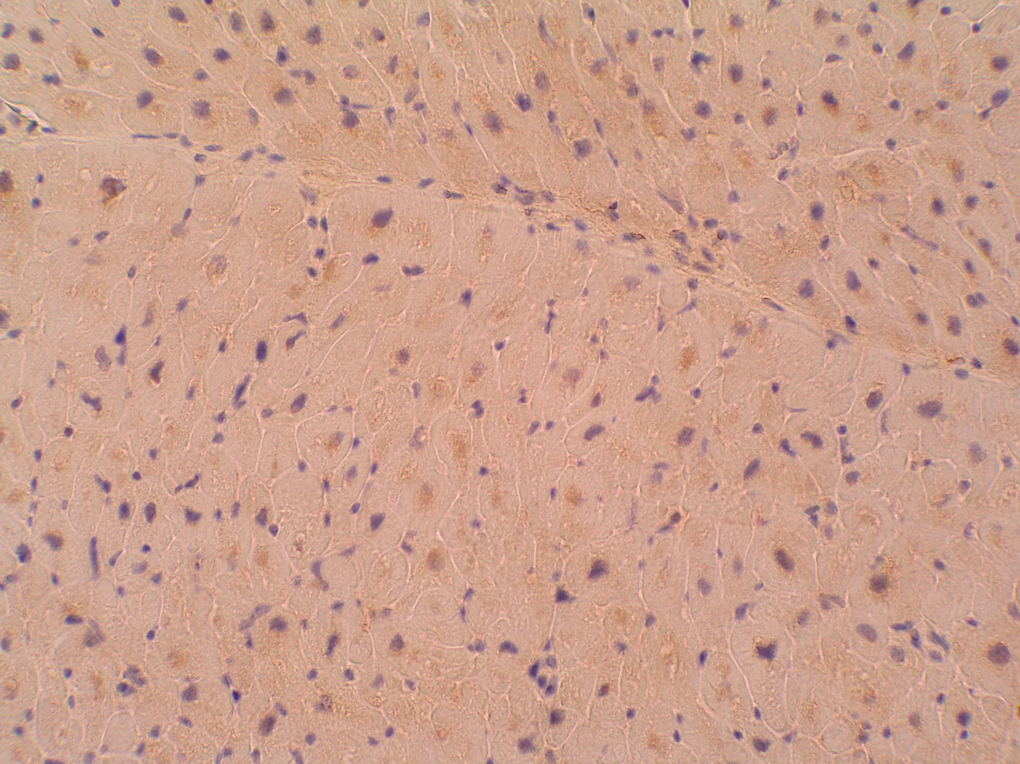

Subpicture: In normal heart myocytes, myostatin is expressed in the peri-nuclear and cytoplasmic area. In this case, low reactivity myostatin is evident. (Magnification x 250)

FIGURE 2. Increased cardiac Myostatin immunohistochemmical expression in human alcoholic dilated cardiomyopathy.

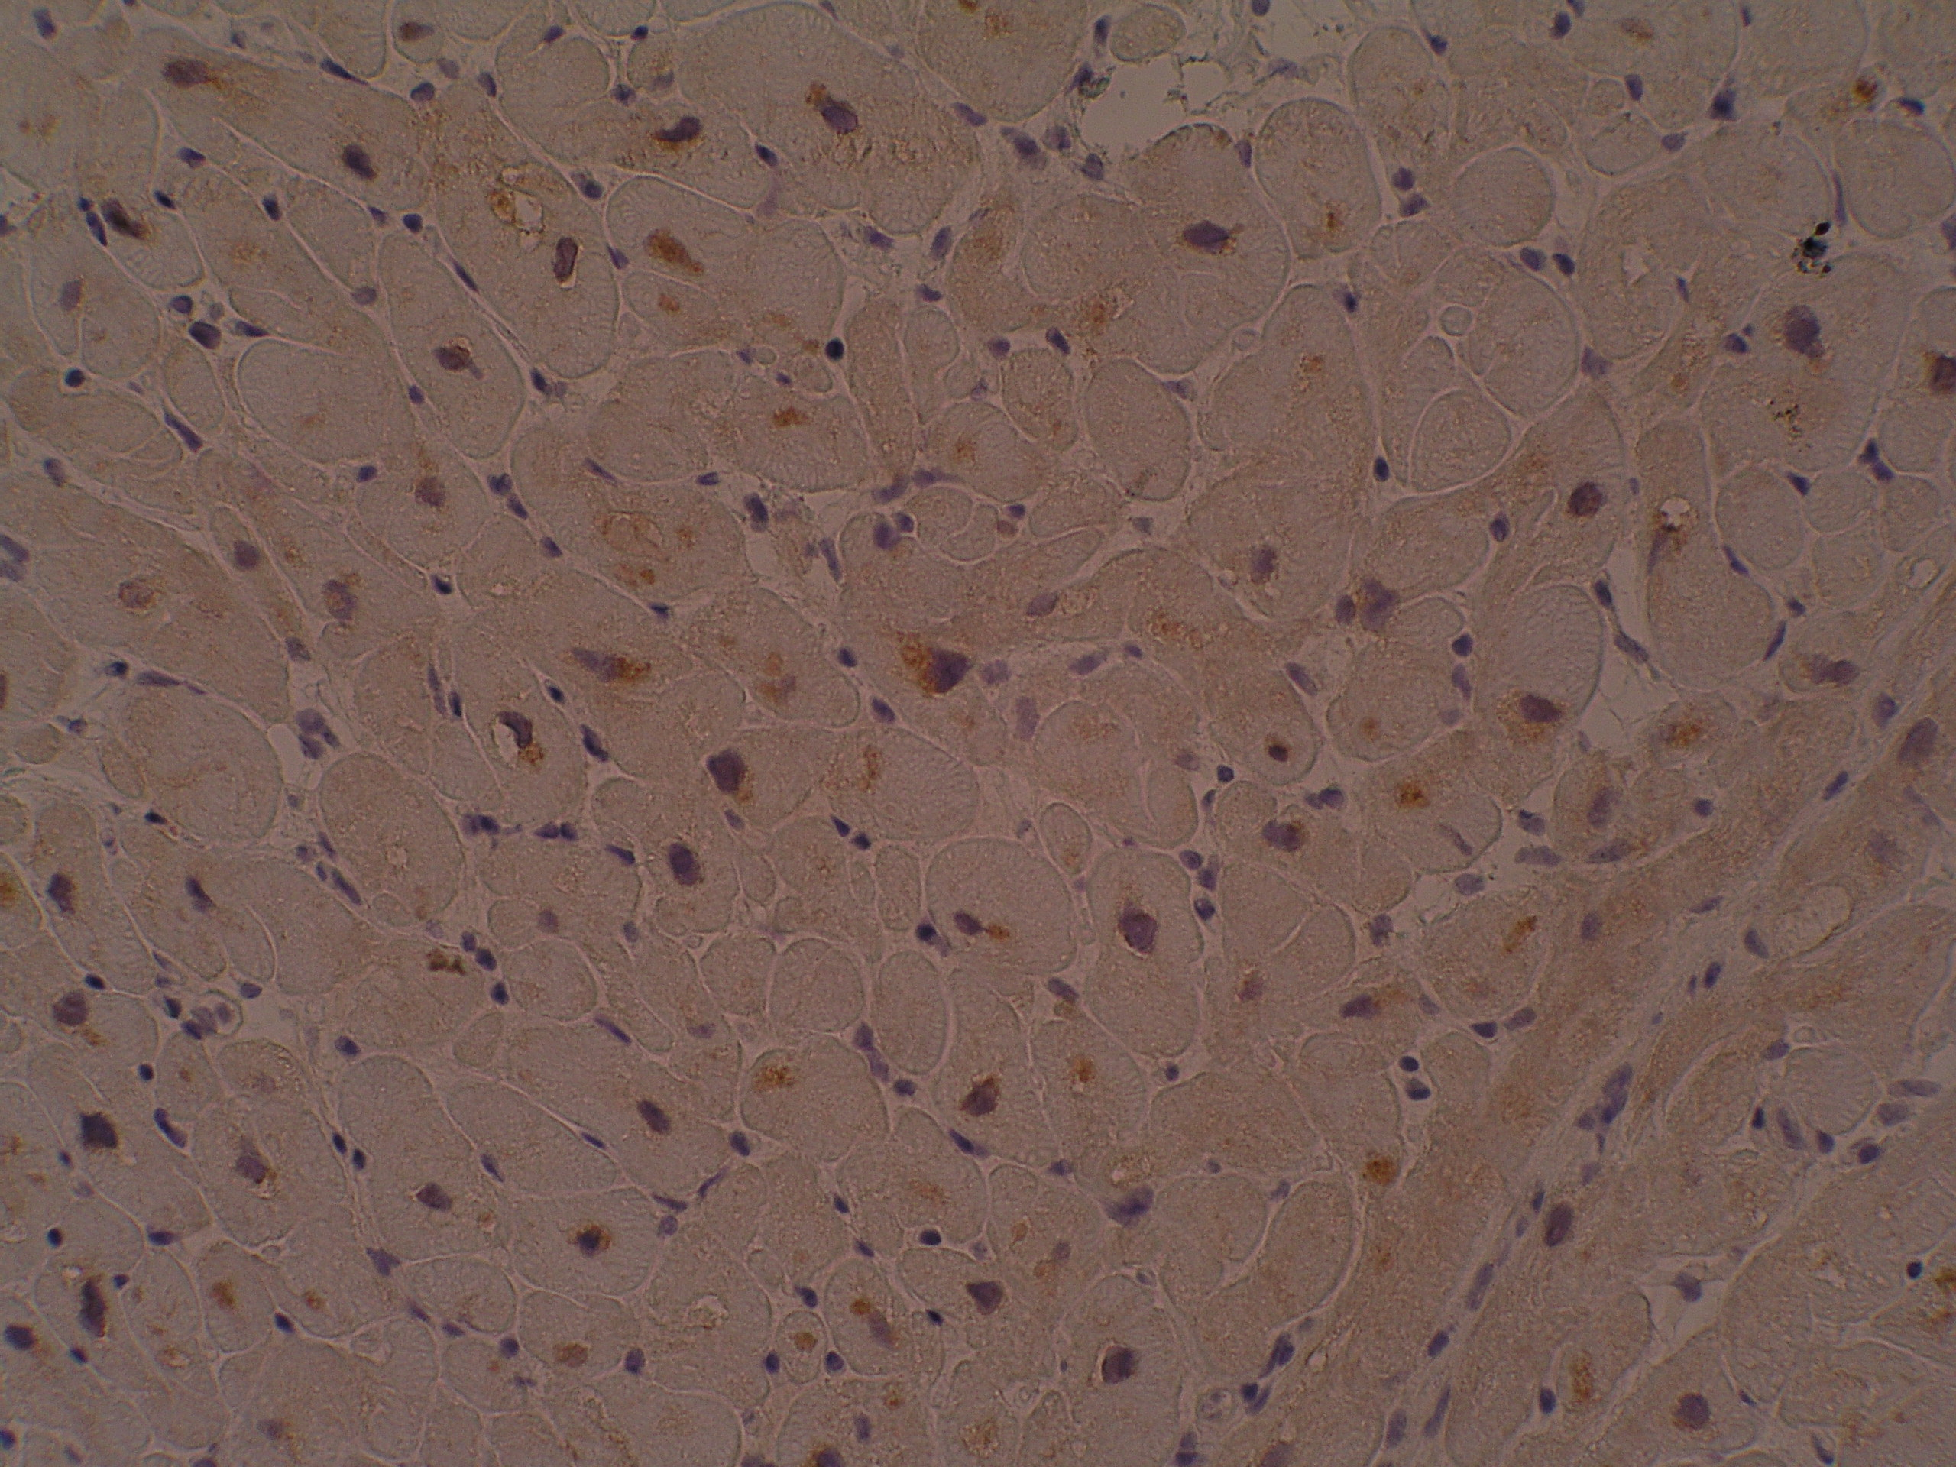

Subpicture: In this case of a donor with alcoholic cardiomyopathy, myostatin
shows a brown perinuclear and cytoplasmic high-reactivity (arrows). (Magnification x 250)

