Platelet-rich plasma and simultaneous wound suturing for treatment of ischial pressure sores

Taiju Fujimura, M.D.,Ph.D;

Department of Plastic and Reconstructive Surgery, Kyoto Okamoto Memorial Hospital

Corresponding Author: Taiju Fujimura

Department of Plastic and Reconstructive Surgery
Kyoto Okamoto Memorial Hospital

Kumiyama-cho Sayama Nishiokuchi 58, Kuze-gun,
Kyoto, Japan
613-0034

Phone: +81-774-48-5500
Fax: +81-774-44-7159
E-mail: taiju@nn.iij4u.or.jp

Abstract
The cause of ischial sore is synovial bursa which is made of pressure or shear on the ischial bone. Because of this mechanism, ischial sore often has big subcutaneous pocket compared to its skin defect. To treat this ischial ulcer, complete pocket resection and reconstruction with appropriate flap is the popular way, but we could treat five relapsing ischial sores by applying PRP and direct closing. Ischial sores are often found on the buttock of paraplegia patients who keep sitting on wheel chairs long time. They have high possibility of recurrence of ischial sores as long as using wheel chairs. This method is useful for them because no normal tissues around sore is resected and possibility of using local flaps can be remained when sore relapse.

Introduction
Complete pocket resection and flap reconstruction is widely applied for the treatment of ischial pressure sores (IPSs) [1]. However, IPSs have high incidence of recurrence. When a large flap is created, surgical scars surrounding IPSs may impede future treatments. Thus, we evaluated the efficacy of platelet-rich plasma (PRP) and immediate closure via direct suturing. Our results showed that this method is useful because no normal tissues around the wound are resected and can possibly be used again as local flaps upon IPS recurrence. We report the effectiveness of PRP therapy and direct wound closure for the treatment of IPSs.

Patients and Methods
Patients
Five patients with IPSs (age, 17–76 years) were treated by the application of PRP and direct wound closure via suturing. All of the included patients with IPSs had histories of surgical intervention. The size of the skin defects ranged from 14 × 34 mm to 23 × 52 mm, and the size of the subcutaneous pockets ranged from 45 × 70 mm to 100 × 110 mm (Table I).

Processing PRP
Immediately before surgery, PRP was created by drawing peripheral venous blood (30–50 ml) and centrifuging twice (low-speed centrifugation at 400 g for 8 min followed by high-speed centrifugation at 2300 g for 12 min). The number of platelets, red blood cells (RBCs), and white blood cells were counted before and after centrifugation (Table II). No activator for PRP was used.

Surgical procedure
All surgeries were performed under local or lumbar anesthesia. The remaining necrotic tissue was removed using scissors or curettes. Autologous PRP was applied to the surface of granulation tissue, and the wound edge was refreshed and then directly closed. If the tension of the sutured wound edge seemed too great, a relaxation incision was made. Suction drainage was not used except for in one case in which broad undermining was performed to reduce tension of the wound edge. The patients were advised not assume a sitting position for 2 weeks following surgery, during which they were supplied with decompression mattresses for wheel chairs and physical rehabilitation, including push-ups, was recommended.

Case 1
Patient 1 was a 75-year-old male with recurrent IPS as a result of limited mobility following spinal injury. This patient underwent multiple surgeries and an advanced flap reconstruction 1 year before the treatment for IPS, but the sore reoccurred at the same site (Figure 1(a)). Because of an aggravated infection, he was admitted to our hospital and bedside debridement and irrigation were performed over several days. Just before wound closure, the size of the skin defect was 32 × 33 mm and the pocket size was 50 × 75mm (Figure 1(b)). A skin incision was made on the border of the pocket and the wound surface was curetted under direct observation. After sufficient irrigation, PRP was applied to the wound bed. Then, the wound edge was directly closed and no drainage tube was inserted. We achieved good adhesion of the wound edge, and all sutures were removed 1 week after operation. This patient experienced no recurrence 2 years after surgery (Figure 1(c)).

Case2
Case 2 was a 62-year-old male with spinal injury resulting from a traffic accident 40 years before. The patient experienced multiple bilateral IPS recurrences. Upon admission to our hospital, he had a 75 × 22 mm IPS on his left ischium (Figure 2(a)). Initially, we created a V-Y advancement flap from his posterior thigh, but wound dehiscence occurred 1 month later. After several rounds of bedside debridement and irrigation, the wound bed was cleared of infection. Finally, the size of the skin defect was 23 × 52 mm and the pocket size was 50 × 100 mm. We performed curetting of the wound surface, applied PRP, and directly closed the wound with sutures (Figure 2(b)(c)). We achieved good wound adhesion and no recurrence was detected at a 1-year follow-up (Figure 2(d)).

Case 4
Case 4 involved a 17-year-old paraplegic female with congenital spina bifida. She had undergone two previous surgeries to correct a left-side IPS. She was admitted to our hospital for the treatment of her infectious wound, which was irrigated and debrided daily. After the infectious symptoms subsided, we performed surgery. The size of the skin defect was 31 × 42 mm, and the pocket size was 45 × 70 mm (Figure 3(a)). The wound edge tension was significant because of prolonged inflammation and abundant scarring. Before applying PRP, we made some incisions to relax the skin and then created a rotation flap over the pocket (Figure 3(b)(c)). Considering the wide depression, two drainage tubes were inserted and maintained under low suction force (Figure 3(d)). No signs of hematoma or seroma were detected postoperatively, and the drainage tubes were removed after 3 days. Good wound adhesion was achieved, and no recurrence occurred 2 years after surgery (Figure 3(e)).

Discussion
The ischium and the superior soft tissue support a significant portion of the body’s mass when in a sitting position. In patients who spend prolonged periods in the sitting position, especially those with spinal cord injuries, the ischium bears a disproportionate amount of body’s mass for sustained periods and is therefore more susceptible to IPS development [1]. It is well known that the cause of IPSs is synovial bursa, which develops in response to pressure or shear forces acting on bone. Because of this mechanism, IPSs often have a relatively large pocket compared to the accompanying skin defect [2], which is most often treated via complete pocket resection and reconstruction with an appropriate flap [3,4]. However, because IPSs have high recurrence rates, many other conservative treatment modalities have been developed. One of the most popular treatment for IPSs is sclerotherapy via injection of highly concentrated ethanol to adhere the pocket wall [5]. Other groups have reported use of basic fibroblast growth factor [6] and negative pressure wound therapy [7]. In this series, we treated five cases of relapsing IPS through the application of PRP and direct wound closing using sutures.
PRP therapy was first reported by Marx et al. in 1988, who applied the process for mandible reconstruction [8]. Since then, PRP therapy has been effectively applied to many types of soft tissue repairs and there are also many reports of its effectiveness in wound healing [9,10]. Platelets contain alpha granules that release several types of cytokines to promote wound healing, vascular synthesis, granulation, and epithelization.
In the present cases, we did not completely remove the bursal surface but could treat the sores appropriately nonetheless. PRP can transform a chronic wound surface into an acute wound surface through the action of transforming growth factor beta contained in alpha granules that, in turn, activate fibronectin, which subsequently strongly promotes scar adhesion in the bursa [11]. However, if too many RBCs are contained in PRP, the cyst may form a hematoma following wound infection. Therefore, we confirmed the RBC count of PRP before and after centrifugation. As shown in Table II, the number of platelets increased 9- to 22-fold, which reportedly is indicative of the effectiveness of the treatment [12]. However, in some cases, the number of RBCs also slightly increased simultaneously.
In our case series, we did not experience an incidence of hematoma. When PRP is applied in pockets, the number of RBCs should be carefully monitored to avoid the development of a hematoma especially. We controlled the number of RBCs in PRP through aspiration of the RBC layer after the first centrifugation; however, it is difficult to effectively concentrate platelets while reducing the number of RBCs with this method.
We did not use an activator, such as thrombin or calcium chloride, to thicken the activated PRP to a gel. When using PRP in a pocket, as in the present cases, a gel form of PRP is not necessary because many inherent activators infiltrate the wound pocket, thereby negating the need to activate PRP prior to its application. Moreover, Sandra et al. [13] reported that activated PRP is less effective in wound management.
In two of the presented cases, we added some incision to relax the skin but were careful not to remove too much tissues. The main causative factor for IPSs is maintaining a sitting position in a wheelchair for prolonged periods, especially in paraplegic patients. Surgeons who treat IPSs must take care to reduce the extent of tissue excision. We also routinely reduce the amount of scar tissue and close the wound by direct suturing. Many IPSs have only small skin defects and most can be closed directly without creating additional tension, although tension on the wound edge can be alleviated by a small relaxation incision and creating a rotation flap.

In conclusion, immobile patients are not good candidates for high-risk surgical procedures under general anesthesia; therefore, the proposed PRP therapy and direct suturing method can be performed under local anesthesia to effectively close IPSs.

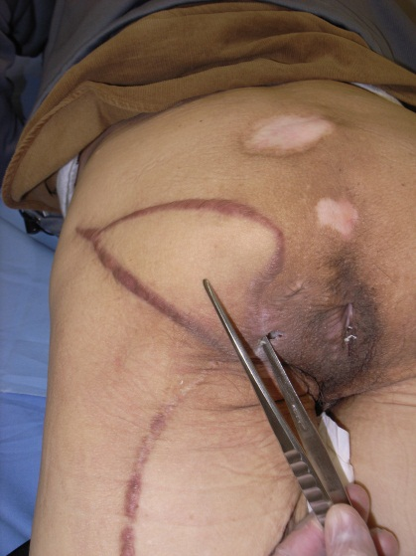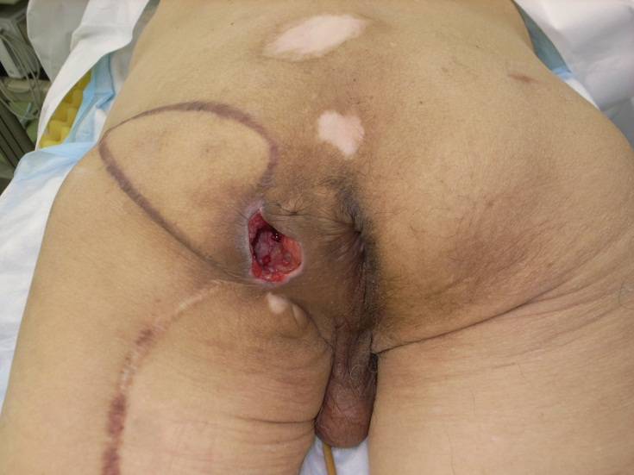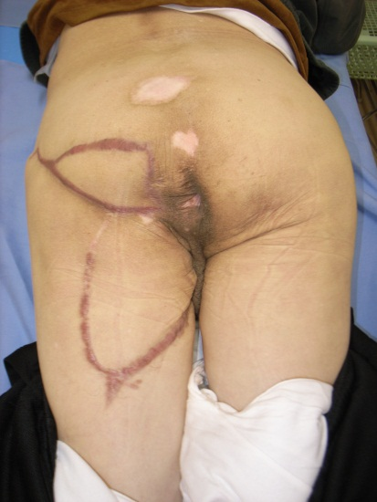

Fig1 (a)(b)(c)

Figure 1.
- A recurrent IPS of the left ischium. The subcutaneous pocket was relatively large compared to the skin defect.
(b) After resection, an incision was added to maintain the wound edge.
(c) The wound as it appeared 3 years after surgery.

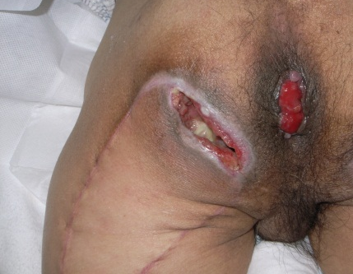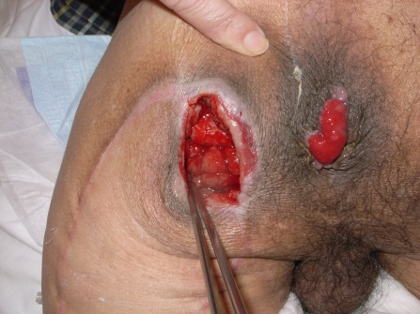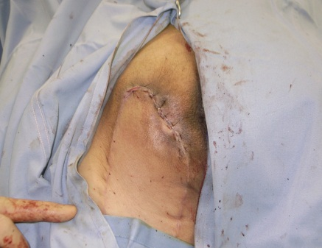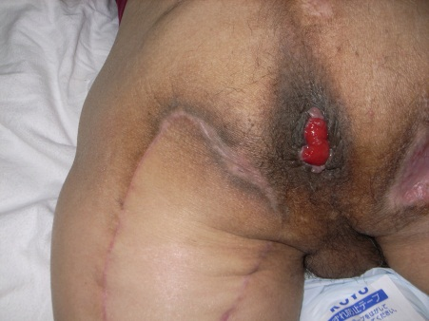

Fig2(a)(b)(c)(d)

Figure 2.
- A recurrent IPS of the left ischium. After posterior thigh flap reconstruction, the wound edge was detached.
(b and c) PRP was applied in the pocket, and the wound was closed immediately.
(d) The wound as it appeared 1 year after surgery.

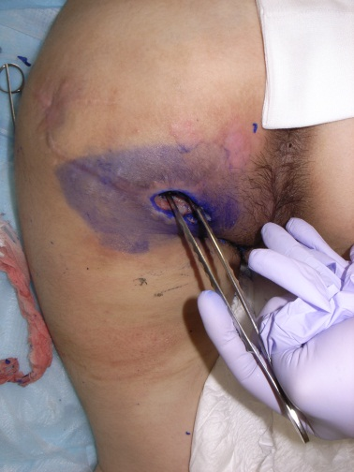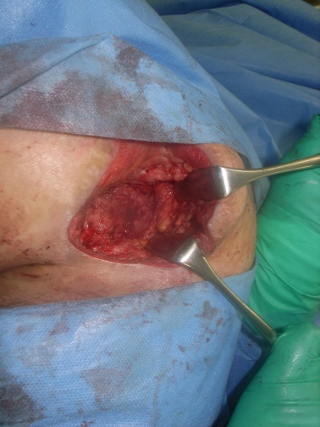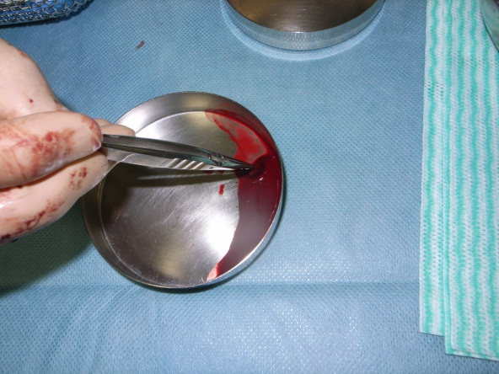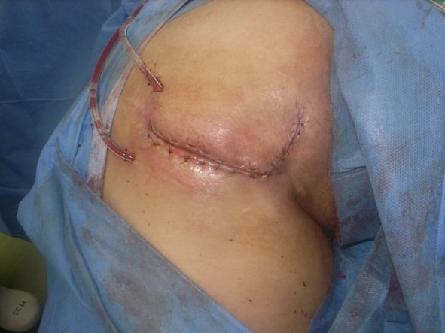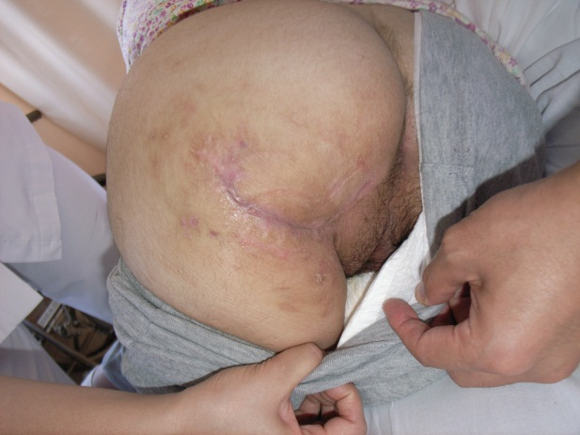

Fig3(a)(b)(c)(d)(e)

Figure 3. (a) A recurrent IPS of the left ischium.
(b–d) After resection of the scar tissue, the wound edge was maintained. PRP
was applied and the wound was closed immediately.
(e) The wound as it appeared 2 years after surgery.

Table I

Case no. | Side of sore | Age/Gender | Size of skin defect (mm) | Size of pocket (mm) | Treatment method
1 | left | 76/M | 12 × 23 | 50 × 75 | PRP + direct suture
2 | left | 63/M | 23 × 52 | 50 × 100 | PRP + direct suture
3 | right | 43/M | 20 × 30 | 100 × 110 | PRP + direct suture  + relaxing incision
4 | left | 17/F | 31 × 42 | 45 × 70 | PRP + direct suture  + relaxing incision
5 | right | 61/F | 14 × 34 | 80 × 95 | PRP + direct suture

Table I. Patient characteristics

Table II

Case no. | No. of platelets before centrifugation | No. of platelets after centrifugation | Concentration | No. of RBCs before centrifugation | No. of RBCs after centrifugation | Concentration | No. of WBCsbefore centrifugation | No. of WBCsafter centrifugation | Concentration
1 | 222 | 4045 | 18.22 | 3.88 | 3.80 | 0.98 | 4.97 | 66.6 | 13.4
2 | 219 | 2037 | 9.30 | 4.85 | 5.42 | 1.12 | 6.21 | 55.3 | 8.90
3 | 356 | 7812 | 21.9 | 3.93 | 3.22 | 0.82 | 7.31 | 111.6 | 15.3
4 | 203 | 3184 | 15.7 | 4.28 | 4.45 | 1.04 | 5.94 | 66.2 | 11.14
5 | 214 | 2536 | 11.85 | 3.67 | 4.32 | 1.18 | 7.1 | 63.8 | 8.99
RBCs, red blood cells; WBCs, white blood cells

Table II. RBC counts before and after centrifugation.
References
- Nakanishi H, Seike T. Characteristics and surgical treatment for ischial pressure sores. Jpn J Plast Reconstr Surg 2003;46:567-75.
- Homma K, Murakami G, Fujioka H, et al. Treatment of ischial pressure ulcers with a posteromedial thigh fasciocutaneous flap. Plast Reconstr Surg 2001;108:1990-6.
- Lin H, Hou C, Chen A, et al. Long-term outcome of using posterior-thigh fasciocutaneous flaps for the treatment of ischial pressure sores. J Recontr Microsurg 2010;26:355-8.
- Ahluwalia R, Martin D, Mahoney JL. The operative treatment of pressure wounds: a 10-year experience in flap selection. Int Wound J 2010;7:103-6.
- Hayashi T. Treatment of ischial pressure sores by means of sclerothrapy using absolute ethanol. Ann Plast Surg 2004;53:554-9.
- Ono T. Treatment of sacral pressure ulcer with giant pocket utilizing trafermin. Mie Med 2005;49:25-9.
- Baynham SA, Kohlman P, Katner HP. Treating stage IV pressure ulcers with negative pressure therapy: a case report. Wound Manage 1999;45:28-32,34-5.
- Marx RE, Carlson ER, Eichstaedt RM, et al. Platelet-rich plasma-growth factor enhancement for bone grafts. Oral Surg Oras Med Oral Pathol Oral Radiol Endod 1998;85:638-46.
- Scott AS, Jeffery JE, Timothy WR, et al. A case report on the use of sustained release platelet-rich plasma for the treatment of chronic pressure ulcers. J Spinal Cord Med 2011;34:122-7.
- Scimeca CL, Bharara M, Fisher TK, et al. Novel use of platelet-rich plasma to augment curative diabetic foot surgery. J Diabetes Sci Technol 2010;4:1121-6.
- Ogawa Y, Sawamura SJ, Ksander GA, et al. Transforming growth factors-beta 1 and beta 2 induce synthesis and accumulation of hyaluronate and chondroitin sulfate in vivo. Growth Factors 1990;3:53-62.
- Gonshor A. technique for producing platelet-rich plasma and platelet concentrate. Int J Periodontics Restorative Dent 2002;22:547-57.
- Sandra SS, Mickael T, Enrico V. Nonactivated versus thrombin-activated platelets on wound healing and fibroblast to myofibroblast differentiation in vivo and in vitro. Plast Reconstr Surg 2012;129:46e-54e.

