
THE EUROPEAN SOCIETY OF MEDICINE
Medical Research Archives, Volume 13 Issue 11
RESEARCH ARTICLE
Efficacy and Safety of 5% Cysteamine versus 4% Hydroquinone in Indian Patients with Melasma: A Randomized, Open-label Study
Imran Majid¹, Dhiraj Dhoot², Zukhruf Wani³, Somia Mushtaq⁴ Ashwin Balasubramanian⁵

¹MD; FRCP (Edinburgh); Director Cutis Institute of Dermatology, Srinagar, Kashmir
²Global Medical Affairs, Glenmark Pharmaceuticals Limited, Mumbai, India.
³Resident Doctor Cutis Institute of Dermatology, Srinagar, Kashmir
⁴Resident Doctor Cutis Institute of Dermatology, Srinagar, Kashmir
⁵Manager Glenmark Pharmaceuticals Limited, Mumbai, India.

OPEN ACCESS

PUBLISHED
30 November 2025

CITATION
Majid, I., et al., 2025. Efficacy and Safety of 5% Cysteamine versus 4% Hydroquinone in Indian Patients with Melasma: A Randomized, Open-label Study. Medical Research Archives, [online] 13(11).
https://doi.org/10.18103/mra.v13i11.6992

COPYRIGHT
© 2025 European Society of Medicine. This is an open- access article distributed under the terms of the Creative Commons Attribution License, which permits unrestricted use, distribution, and reproduction in any medium, provided the original author and source are credited.

DOI
https://doi.org/10.18103/mra.v13i11.6992

ISSN
2375-1924

ABSTRACT
Background: Hydroquinone (HQ) is the standard induction therapy for melasma, while cysteamine (CYS) offers a non-melanocytotoxic alternative potentially suitable for long-term use. But due to paucity of real-world comparative studies between the two in India, we compared the efficacy and safety of 5% CYS versus 4% HQ in patients with facial melasma.

Methods: This randomized, open-label, single-center study enrolled 55 adults who were assigned to either CYS 5% or HQ 4% for 16 weeks with standardized photoprotection. Co-primary endpoints were percentage change in Melasma Severity Index (MSI) and modified Melasma Area and Severity Index (mMASI) at Week 16. Secondary outcomes included change in melanin index and safety assessments.

Results: Of 55 randomized patients, 30 completed the study (HQ 14, CYS 16). At Week 16, MSI and mMASI decreased significantly in both groups (HQ −64.2% and −48.4%; CYS −40.7% and −30.6%). Melanin index reduced by 22.0% and 10.6% in HQ and CYS groups respectively. Between-group differences favored HQ at Week 4 (MSI: 27.08%, p=0.004; mMASI: 18.14%, p=0.008) and Week 8 (MSI: 21.48%, p=0.024), but narrowed by Week 16 (MSI p=0.064; mMASI p=0.090). Three patients (10.7%) in HQ and four patients in CYS (14.8%) discontinued the treatment due to adverse events and 18 patients were lost to follow-up. But overall, both the treatments were well tolerated.

Conclusions: More rapid pigment lightening was achieved with HQ, while CYS showed gradual but accumulating improvement over 16 weeks. Findings support HQ as an induction option when faster onset is desired and CYS as an option for long-term therapy in melasma management.

Keywords: Melasma, Cysteamine, Hydroquinone, mMASI, MSI, Mexameter, Efficacy, Safety, Tolerability

Introduction
Melasma is a frequently occurring skin disorder marked by development of gray- brown patches on the face. It mostly affects the cheeks, bridge of the nose, forehead, upper lip and chin.^{[1]} Melasma affects women more commonly than men and is often triggered by factors such as sun exposure, hormonal fluctuations and physical/emotional stress.^{[1-3]} Sunlight exposure is considered to be the major trigger and aggravating factor in melasma in both males as well as females.^{[2-4]} Hormones plays a key role in melasma, as the disease is seen in the reproductive age group and there is worsening during pregnancy and with the use of oral contraceptive pills.^{[2,3]} Melasma is associated with considerable psychological impact and has been shown to significantly impair the quality of life and emotional well-being of the patient.^{[5]} As with the other dermatological conditions, the implementation of valid and reliable scoring system is crucial for objective assessment of the disease severity and the evaluation of therapeutic efficacy.^{[2]} The most widely utilized assessment tools for melasma include the Melasma Area and Severity Index (MASI) and its modified version (mMASI), both of which evaluate the extent of affected areas as well as the intensity of pigmentation.^{[3]} Recently, alternative scoring system called as Melasma Severity Index (MSI) has also been developed for clinical and research applications.^{[6,7]}

Melasma may resolve spontaneously, particularly when triggered by transient factors such as pregnancy or certain medications. In such cases the pigmentation often fades following childbirth or discontinuation of offending medications. However, in most individuals, melasma can persist for several years or even become a chronic condition.^{[1]} Although it poses no physical harm, the cosmetic and psychological impact leads many patients to seek treatment.^{[5]} There is currently no universally effective treatment for melasma. Management typically involves a multifaceted approach, with the most effective outcomes observed when strict photoprotection is combined with topical pharmacologic agents like depigmenting agents like hydroquinone (HQ), retinoids, azelaic acid, and kojic acid. Topical HQ or triple therapy combination creams remain the most effective treatments for melasma.^{[8]} However, both these treatment options have been associated with certain adverse effects, especially with their long-term use. These adverse effects include erythema and xerosis, contact allergic reactions increased skin sensitivity, and exogenous ochronosis.^{[1,8,10]} A growing number of botanical and phytochemical agents are used as safer alternatives to HQ and these treatment options can be used as first-line treatments or as maintenance regimens in melasma.^{[11,12]}

Cysteamine (CYS) hydrochloride, a stable amino thiol (betamercaptoethylamine) has been used as an effective treatment option in melasma with the advantage of having potent antioxidant properties. Unlike HQ, its mechanism of action is not melanocytotoxic, suggesting a potentially safer profile for long-term use.^{[13,14]} Randomized trials and meta-analyses demonstrate that 5% CYS can reduce MASI/ mMASI scores and, in some studies, performs comparably to HQ-based regimens.^{[15-17]} Despite its promise, there is a paucity of clinical data from the Indian subcontinent regarding the efficacy of CYS versus HQ in melasma treatment, hence we conducted this study.

Material and Methods
This prospective, randomized, open label study was conducted at our institute from July 2024 to April 2025 on 55 patients of melasma after obtaining independent ethics committee approval (lslamic University of Science and Technology). The patients were recruited from the routine outpatient department of the institute after assessing their eligibility and an informed written consent. This clinical study was performed in accordance with Good Clinical Practices and the Declaration of Helsinki of 1975 as revised in 2000, and was registered with the Clinical Trials Registry of India (CTRI/2024/04/066500).

Participants were randomized if they met all of the inclusion criteria which included adults aged between 18 and 60 years, in good general health, with no active infectious or progressive conditions that could compromise their safety or interfere with study outcomes. Participants were excluded from the study if they were pregnant, breastfeeding, or if they declined to provide informed consent by failing to sign the consent form. Patients with insulin-dependent diabetes mellitus, or non-insulin-dependent diabetes with treatment initiated within the past six months, bronchial asthma, epilepsy, non-stabilized thyroid disease, or cutaneous hypersensitivity to any ingredient in the study products were excluded from the study. Patients on chronic medical treatment with aspirin, anti-inflammatory drugs, antihistamines, or corticosteroids administered by systemic or topical routes were also excluded.

A total of 55 patients were randomized in a 1:1 ratio into two groups, with one group assigned to receive topical cysteamine 5% cream (CYS group) and the other to receive topical hydroquinone 4% cream (HQ group) once daily at bedtime. The sample size accounted for an anticipated dropout rate of 20% and was calculated to provide 90% statistical power to detect a minimum difference of 0.45 between group proportions. The calculation was based on a two-sided Fisher’s Exact Test, with the level of statistical significance set at 0.05.

After inclusion and randomization, all the patients were photographed using a single camera with standard lighting conditions and the melasma severity was assessed by using modified Melasma Area and Severity Index (mMASI) score, Melasma Severity Index (MSI) score, and calculation of melanin index using a spectrophotometer (Mexameter- Courage and Kazakha company, Germany). The patients in HQ group were prescribed 4% hydroquinone cream for once daily overnight application at bedtime while those in the CYS group received topical cysteamine cream to be applied for 30 minutes once daily at bedtime. All the patients were prescribed a similar physical zinc-oxide based sunscreen cream to be applied at least twice daily in the morning and afternoon. All the enrolled patients also received a similar non-comedogenic moisturizing cream and a mild facial cleanser as part of the treatment regimen.
Patients were given a diary to be filled at the time of drug application to check for compliance to daily treatment and were advised to restrict sun exposure. Patients were followed up every two weeks for the first month and then monthly for the next 3 months for a total duration of 16 weeks. The objective assessment with mMASI score, MSI score was carried out at the initial visit and at each follow up visit. Calculation of melanin index with Mexameter was done at the initial visit and then at 3-month and 4-month follow-up visit only.

Safety assessments were performed throughout the study and included the documentation of adverse events (AEs) and serious adverse events (SAEs), as reported by the participants or observed by the treating physician. The physician determined whether the events were related to the study medications.

The primary endpoint of the study was percentage improvement in MSI and mMASI scores from baseline. These scores were assessed by a certified dermatologist on Day 0, 14, 28, 56 and 112, with baseline values serving as the reference point for comparison.

The secondary endpoints included any adverse effects and the percent reduction in melanin content of the pigmented areas, which was measured using a Mexameter.

Results
A total of 55 patients with moderate-to-severe melasma were enrolled and randomized to either the CYS group (n=27) or HQ group (n=28), and 15 participants from either group completed the study as shown in Figure 1.

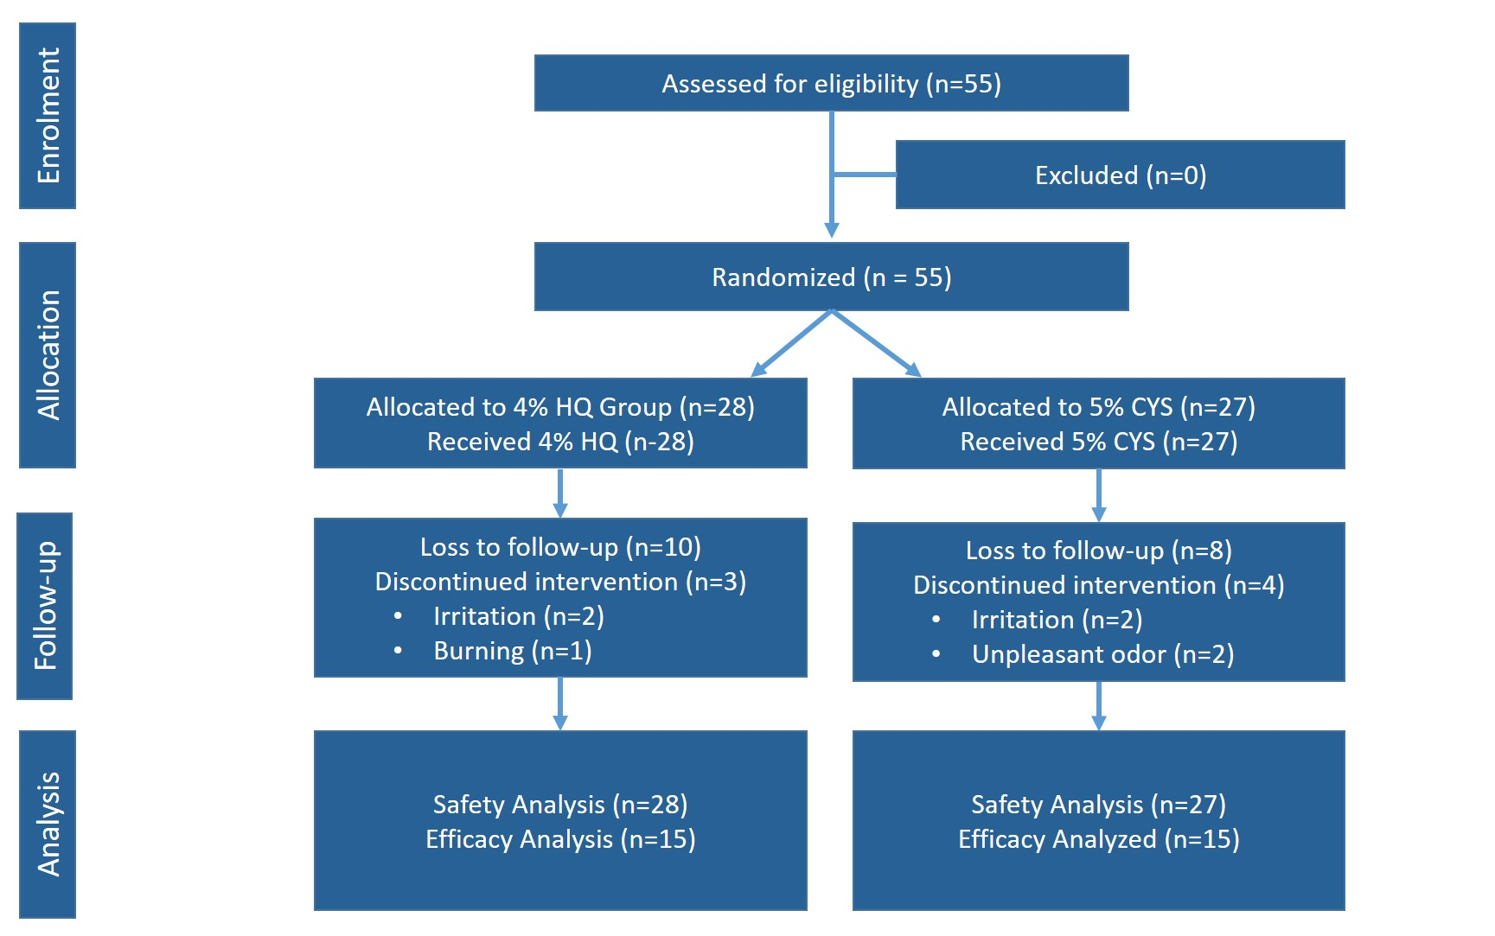

Figure 1. Participant Flow and Disposition as per CONSORT

Table 1. Baseline Disease Severity Indices in Cysteamine and Hydroquinone Groups and Normality testing

Variable | Hydroquinone (n=28) | Cysteamine (n=27) | p-value | Test | Normality (Shapiro–Wilk)
MSI at V1 | 18.54 ± 12.86 | 16.13 ± 12.23 | 0.479 | Mann–Whitney U | No (p=0.0048; 0.00002)
mMASI at V1 | 6.47 ± 3.43 | 6.16 ± 3.65 | 0.613 | Mann–Whitney U | Yes (p=0.050; 0.0072)
Melanin at V1 | 341.74 ± 73.36 | 310.02 ± 66.43 | 0.099 | t-test | Yes (p=0.877; 0.589)

MSI = Melasma Severity Index; mMASI = modified Melasma Area and Severity Index.
Data shown as mean ± SD.
*p < 0.05; **p < 0.01 = significant (Mann–Whitney U or t-test as appropriate) Shapiro–Wilk test: p<0.05 = non-normal.

The two groups were well-matched at baseline with respect to demographic and clinical variables. There were no significant differences between groups in initial MSI, mMASI, and Mexameter-derived melanin index scores. Most variables did not follow a normal distribution, which guided the choice of non-parametric statistical methods for subsequent analysis (Table 1).

Both treatment arms demonstrated significant within-group improvements across all major outcome measures, including MSI, mMASI, and Melanin Index. In the Hydroquinone group, MSI scores fell from a mean of 19.0 at baseline to 6.8 at Week 16—a reduction of over 64% (p=0.001) (Figure 1a,b). In the Cysteamine group, MSI improved from 16.1 to 9.6 during the same period, corresponding to a 41% decrease (p=0.001) (Fig 2a,b). This pattern of marked improvement was echoed in mMASI scores, which declined by 48% in the Hydroquinone group and by 31% in the Cysteamine group by Week 16, with both changes reaching statistical significance. Melanin index scores also improved significantly in both groups, though the magnitude of change was consistently greater with Hydroquinone. (Table 2).

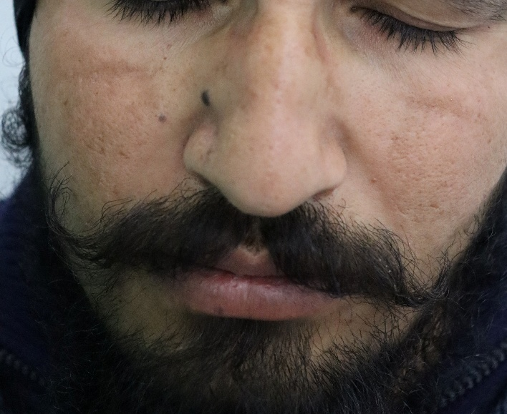
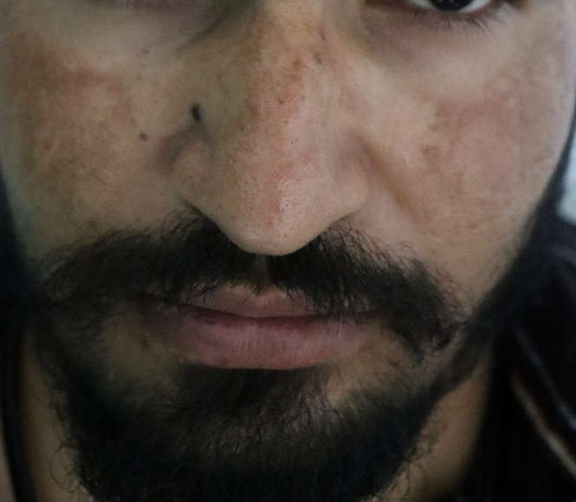

Fig 1a,b: Melasma with good response to Hydroquinone

Table 2: Intragroup Change in Disease Severity Indices Over Time (Hydroquinone and Cysteamine)

Group | Endpoint | Baseline (mean±SD) | Week 4 | Week 8 | Week 16 | % Change at Week 16 | p-value (Baseline vs W16)
Hydroquinone | MSI | 18.97 ± 13.34 | 12.62 | 8.38 | 6.79 | -64.2% | 0.001**
Cysteamine | MSI | 16.09 ± 11.95 | 14.49 | 11.32 | 9.59 | -40.7% | 0.001**
Hydroquinone | mMASI | 6.74 ± 3.50 | 5.01 | 4.04 | 3.41 | -48.4% | 0.001**
Cysteamine | mMASI | 6.12 ± 3.63 | 5.65 | 4.59 | 4.25 | -30.6% | 0.001**
Hydroquinone | Melanin | 349.84 ± 74.33 | — | 284.15 | 272.63 | -22.0% | 0.001**
Cysteamine | Melanin | 308.70 ± 67.27 | — | 288.90 | 279.12 | -10.6% | 0.001**

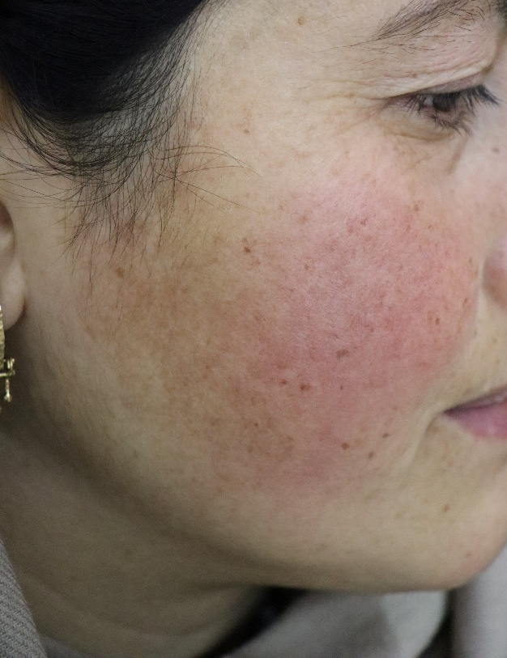
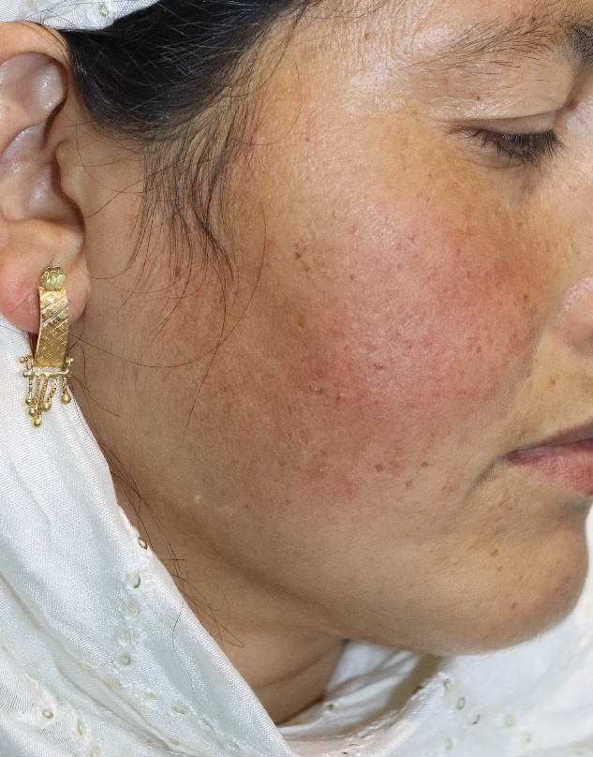

Fig 2a,b: Melasma with good response to Cysteamine

When comparing percent reductions in these indices between groups, HQ produced more rapid and pronounced improvements at early and intermediate time points. For example, mean MSI reduction at Week 4 was 36.3% in the HQ group versus 9.2% with CYS (p=0.004). By Week 16, the between-group difference in MSI reduction narrowed and was not statistically significant (mean difference 23.3%, 95% CI: 4.0 to 42.6, p=0.064), reflecting the steady and accumulating effect of CYS with continued use (Table 3). A similar trend was observed for mMASI and Melanin Index: HQ achieved greater short-term reductions, while the benefit with CYS became more prominent at later visits.

Table 3. Intergroup Comparison: Percent Reduction from Baseline at Key Time points

Endpoint | Time point | Hydroquinone %∆ (mean±SD) | Cysteamine %∆ (mean±SD) | Mean Difference (95% CI) | p-value
MSI | Week 4 | 36.25 ± 27.97 | 9.17 ± 20.57 | 27.08 (11.40, 42.76) | 0.004**
 | Week 8 | 54.18 ± 22.09 | 32.70 ± 26.80 | 21.48 (4.47, 38.50) | 0.024*
 | Week 16 | 63.43 ± 18.92 | 40.13 ± 33.14 | 23.30 (3.99, 42.61) | 0.064
mMASI | Week 4 | 23.88 ± 23.82 | 5.74 ± 12.98 | 18.14 (6.01, 30.26) | 0.008**
 | Week 8 | 37.23 ± 21.62 | 22.89 ± 21.85 | 14.34 (-0.72, 29.41) | 0.117
 | Week 16 | 48.37 ± 22.75 | 30.09 ± 29.29 | 18.28 (-0.48, 37.05) | 0.090
Melanin | Week 8 | 18.71 ± 14.72 | 7.06 ± 11.47 | 11.65 (2.51, 20.80) | 0.027*
 | Week 16 | 21.44 ± 12.85 | 9.55 ± 11.04 | 11.89 (3.32, 20.47) | 0.023*

MSI = Melasma Severity Index; mMASI = modified Melasma Area and Severity Index.
%∆ (percent change) calculated as (Baseline − Visit)/Baseline × 100.
¹Mean difference = (Hydroquinone mean) – (Cysteamine mean). 95% CI = Mean difference ± t* SEₙ, where SEₙ = √[SD₁²/n₁ + SD₂²/n₂] & t* = T.INV.2T(0.05, n₁+n₂–2)
*p < 0.05; **p < 0.01 = significant (Mann–Whitney U test)

There were 10.7% (n=3) and 14.8% (n=4) treatment-related adverse events which led to discontinuation as given in Table 4. They were categorized as mild-to-moderate by severity. But overall, both treatments were tolerated very well.

Table 4. Treatment-Related Adverse Events

Treatment-Related Adverse Events | HQ (n=28) | CYS (n=27)
AE leading to discontinuation | 3 (10.7%) | 4 (14.8%)
Irritation (%) | 2 (7.1%) | 2 (7.4%)
Burning | 1 (3.6%) | 0 (0.0%)
Unpleasant odour | 0 (0%) | 2 (7.4%)

Discussion
In melasma, HQ remains the treatment of choice in melasma due to its faster onset and strong depigmenting effect.^{[8]} Mechanistically, it acts as a tyrosinase substrate or a competitive inhibitor and can undergo peroxidase-mediated oxidation at higher or prolonged exposure, explaining both efficacy and dose or duration-related irritation potential.^{[8,9]} Adverse effects include irritant or allergic dermatitis, xerosis and, rarely, exogenous ochronosis—hence recommendations to limit continuous duration and pair with rigorous photoprotection.^{[8-10]} CYS is an aminothiol that reduces melanogenesis via tyrosinase and peroxidase inhibition, copper and iron chelation, dopaquinone scavenging, and glutathione elevation, with a non-melanocytotoxic mechanism of action.^{[13, 14]} It is generally well tolerated (transient stinging, odour, and erythema), making it suitable for longer-term maintenance or rotation when prolonged HQ is undesirable.^{[13, 17]} Several clinical studies have reported the therapeutic efficacy and safety of CYS in treating melasma.^{[13-17]}

This randomized, open-label, single-centre study in India was the first of its kind where 5% CYS was compared with 4% HQ for facial melasma over 16 weeks. At week 16, we noticed significant reduction in both the efficacy tools, MSI and mMASI, in both the study groups. As shown in Table 2, in the HQ group, there was reduction by 64.2% and 48.4% in MSI and mMASI respectively whereas same were decreased by 40.7% and 30.6% in the CYS group. Similarly, mean melanin index was decreased by 22% and 10.6% in HQ and CYS group respectively.

Between groups, the early separation was clear on MSI and mMASI as shown in Table 3 at week 4, with the mean difference (MD) percentage in MSI favouring Hydroquinone by 27.08% (p=0.004) and mMASI by 18.14% (p=0.008). At week 8, the MD percentage for MSI was 21.48% (p=0.024), but for mMASI, it was only 14.34% (p=0.117) which was statistically not significant. By week 16, the MD percentage narrowed in MSI (p=0.064) and remained statistically insignificant in mMASI (p=0.090).
Both CYS and HQ were well tolerated in our study, with only mild-to-moderate adverse events recorded (Table 4). Adverse events prompting discontinuation were uncommon in both arms (HQ 10.7%, CYS 14.8%), comprising mainly irritation in both groups, burning in HQ, and odour-related complaints in CYS. The higher early loss to follow-up (HQ 35.7%, CYS 29.6%) likely reflects real-world challenges of treatment compliance, rather than safety signals, but it underscores the importance of adherence counselling and regimen acceptability.

Across various studies and pooled analyses comparing HQ and CYS, HQ tends to show a higher response in the early phase of treatment, while CYS catches up by 12 to 16 weeks, yielding broadly comparable mMASI/MASI reductions at the end of the study – similar to our study findings.^{[15-17]} Published safety literature also describes mild local reactions in both therapies being the most common adverse events; cysteamine is characterized by transient stinging and odor complaints, while HQ carries irritant and xerotic reactions—consistent with our safety findings.^{[9, 15-17]}

In our study, as treatment continued, CYS kept adding incremental benefit; the mean difference percentage between HQ and CYS by Week 16 on MSI and mMASI was not statistically significant, even as HQ retained a numerical edge. This trajectory suggests a rapid induction and eventual tapering with HQ and a slow and steady accumulation with CYS.

Taking into account the results of our study along with existing literature about combination therapies being the preferred approach in the management of melasma,^{[18]} our data points toward a potential hypothesis suggesting that combination therapy of 5% Cysteamine along with 4% Hydroquinone can be considered in management of melasma, from an efficacy perspective. Starting with HQ along with CYS can be considered to harness the early induction from HQ. Around the 8-week mark, HQ may be withdrawn and CYS to be continued for the long-term, as by then the effects of CYS would have accumulated. Withdrawal of HQ is important considering its safety profile as HQ is associated with adverse effects like erythema and xerosis, contact allergic reactions, increased skin sensitivity, and exogenous ochronosis.^{[8, 9]} This rests on (i) the clear early advantage for HQ at Weeks 4–8 on, MSI, mMASI (ii) the narrowing by Week 16 and (iii) the tolerability and adherence edge with CYS that supports prolonged use. The safety profile of CYS allows it to be continued for a long time, and it can even be supplemented by the use of other lightening agents like topical Vitamin C and others as a maintenance treatment in melasma.

The strengths of our study include randomization, usage of both mMASI, MSI, and Mexametry to measure reduction in pigmentation, standardized sunscreen use, and early visits that map the speed of response. Limitations include single-centre design, modest sample size and open-label study design, significant loss to follow-up, and relatively short study duration for a relapsing condition.

Conclusion
In this randomized, open-label, single-center Indian study, both 5% cysteamine (CYS) and 4% hydroquinone (HQ) achieved clinically meaningful improvement in melasma over 16 weeks, with significant MSI/mMASI reductions and corresponding melanin-index decreases in each arm. HQ showed a faster and larger early response, but between-group differences narrowed by Week 16. Both treatments were generally well tolerated with mostly mild-to-moderate local reactions. Collectively, these findings support HQ as an induction option when rapid depigmenting effect is desired and CYS as a long-term option with accumulating benefits.

Acknowledgement:
The authors would like to acknowledge Dr Tasneem Hussain for her insights and support in statistical analysis.

Funding Information:
This study was funded by Glenmark Pharmaceuticals Limited through an unrestricted educational grant. The design and content of the article were in no way influenced by Glenmark Pharmaceuticals Limited.

Conflict of Interest:
Dhiraj Dhoot and Ashwin Balasubramanian are employees of Glenmark Pharmaceuticals Limited. Rest authors declare no conflict of interest.

References:
1. Ogbechie-Godec OA, Elbuluk N. Melasma: An up-to-date comprehensive review. Dermatol Ther (Heidelb) 2017;7:305–18.

2. Lee A-Y. An updated review of melasma pathogenesis. Dermatol Sin 2014;32:233–9.

3. Sarkar R, Arora P, Garg VK, Sonthalia S, Gokhale N. Melasma update. Indian Dermatol Online J 2014; 5:426–35.

4. Castanedo-Cazares JP, Hernandez-Blanco D, Carlos-Ortega B, Fuentes-Ahumada C, Torres-Álvarez B. Near-visible light and UV photoprotection in the treatment of melasma: a double-Blind randomized trial: Visible-light photoprotection in melasma. Photodermatol Photoimmunol Photomed 2014; 30:35–42.

5. Zhu Y, Zeng X, Ying J, Cai Y, Qiu Y, Xiang W. Evaluating the quality of life among melasma patients using the MELASQoL scale: A systematic review and meta-analysis. PLoS One 2022;17:e0262833.

6. Pandya AG, Hynan LS, Bhore R, Riley FC, Guevara IL, Grimes P, et al. Reliability assessment and validation of the Melasma Area and Severity Index (MASI) and a new modified MASI scoring method. J Am Acad Dermatol 2011;64:78–83, 83.e1-2.

7. Majid I, Haq I, Imran S, Keen A, Aziz K, Arif T. Proposing Melasma Severity Index: A new, more practical, office-based scoring system for assessing the severity of Melasma. Indian J Dermatol 2016; 61:39–44.

8. McKesey J, Tovar-Garza A, Pandya AG. Melasma treatment: An evidence-based review. Am J Clin Dermatol 2020;21:173–225.

9. Pollock S, Taylor S, Oyerinde O, Nurmohamed S, Dlova N, Sarkar R, et al. The dark side of skin lightening: An international collaboration and review of a public health issue affecting dermatology. Int J Womens Dermatol 2021;7:158–64.

10. Ishack S, Lipner SR. Exogenous ochronosis associated with hydroquinone: a systematic review. Int J Dermatol 2022;61:675–84.
11. Hollinger JC, Angra K, Halder RM. Are natural ingredients effective in the management of hyperpigmentation? A systematic review. J Clin Aesthet Dermatol 2018;11:28–37.

12. Qian W, Liu W, Zhu D, Cao Y, Tang A, Gong G, et al. Natural skin-whitening compounds for the treatment of melanogenesis (Review). Exp Ther Med 2020;20:173–85.

13. Boo YC. Metabolic basis and clinical evidence for skin lightening effects of thiol compounds. Antioxidants (Basel) 2022;11:503.

14. Cassiano DP, Espósito ACC, da Silva CN, Lima PB, Dias JAF, Hassun K, et al. Update on Melasma-part II: Treatment. Dermatol Ther (Heidelb) 2022; 12:1989–2012.

15. Nguyen J, Remyn L, Chung IY, Honigman A, Gourani-Tehrani S, Wutami I, et al. Evaluation of the efficacy of cysteamine cream compared to hydroquinone in the treatment of melasma: A randomised, double-blinded trial. Australas J Dermatol 2021;62:e41–6.

16. Karrabi M, David J, Sahebkar M. Clinical evaluation of efficacy, safety and tolerability of cysteamine 5% cream in comparison with modified Kligman’s formula in subjects with epidermal melasma: A randomized, double-blind clinical trial study. Skin Res Technol 2021;27:24–31.

17. Mawu FO, Christopher PM. Efficacy and safety of cysteamine 5% cream for the management of melasma: a systematic review and meta-analysis of randomized controlled trials. Arch Derm Res 2024;317:117.

18. Philipp-Dormston WG. Melasma: A step-by-step approach towards a multimodal combination therapy. Clin Cosmet Investig Dermatol 2024;17: 1203–16.

