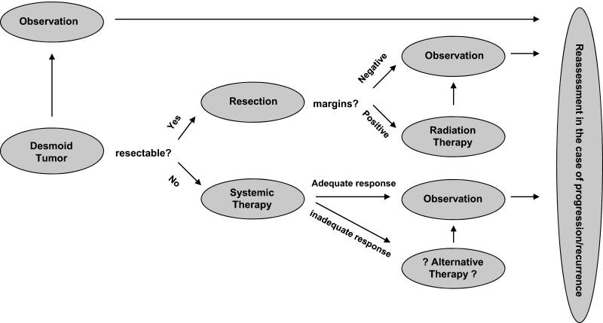
Figure 3: A treatment algorithm for desmoid tumors
Adapted from Lev et al. (Lev D, Kotilingam D, Wei C, et al. Optimizing treatment of desmoid tumors. J Clin Oncol. 2007;25:1785–1791).and Lazar et al. ( Lazar AJF, Hajibashi S, Lev D. Desmoid tumor: From surgical extirpation to molecular dissection. Curr Opin Oncol. 2009;21:352–359).University of Texas MD Anderson Cancer Center.

Figure 1: A 20-year old man; a huge desmoid tumor located in his neck region. (from Toplu Y, Öztanır N, Çetinkaya Z, Koç A, Kızılay A. [Giant desmoid tumor in the neck]. Kulak Burun Bogaz Ihtis Derg. 2014 Sep-Oct;24(5):299-302.)

Figure 2: Photograps of the same patient after two months later (after surgery combined with radiotherapy) (from Toplu Y, Öztanır N, Çetinkaya Z, Koç A, Kızılay A. [Giant desmoid tumor in the neck]. Kulak Burun Bogaz Ihtis Derg. 2014 Sep-Oct;24(5):299-302.)

